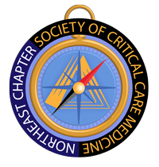
2019 SCCM Northeast Chapter Clinical Congress Scholarship

On behalf of SCCM Northeast Chapter,
We would like to congratulate Ms. Jordan Seaver, RN (Trinity New England-St. Francis Hospital) and Mr. Thomas Manning, PA-C (Yale New Haven Health) as the 2019 SCCM Northeast Chapter Clinical Congress Scholarship winners.
The Northeast Chapter Steering Committee has chosen you both as receivers of the scholarship based on your dedication and commitment to critical care medicine.
We would like to ask you both to please provide a short letter after this year’s Congress and describe your experience. With your permission, we would like to post this short letter on our SCCM-Northeast Website.
Congratulations again and look forward to seeing you in San Diego. Please provide an address so we can mail the scholarship check to you. Any questions, please don’t hesitate to contact us.
Sincerely,
Northeast Chapter Steering Committee
James Lunn, President

