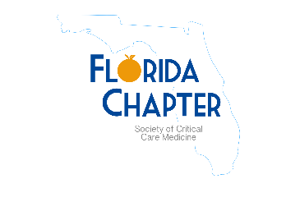
Society of Critical Care Medicine Florida Chapter

Annual Symposium

Saturday, October 22, 2022

Registration
7:30 am  7:30 am – 8:00 am | Registration Opens  Breakfast

Face to Face with Critical Care Experts: Join the Discussion
8:00 am – 8:15 am | Welcome and Opening Session
8:15 am – 9:15 am | Keynote Address  Waking Up to ICU Sleep Disruption and Improvement  Speaker: John Devlin, PharmD, BCCCP, MCCM, FCCP
9: 15 am – 10:15 am | Educating Critical Care Teams – FCCS and SCCM leading the way  Speakers: Luis Llerena, MD, FACS, CHSE-A
10:15 am - 10:30 am | Break
10:30 am- 11:30 am | Dysnatremias in Acute Brain Injury  Speaker: Amay Parikh, MD, MBA, FACP
11:30 am – 12:00 pm | Poster Rounds / Exhibits
12:00 pm – 1:00 pm | Lunch / Exhibits
1:00 pm- 2:00 pm | Round Table Discussions
2:00 pm-3:00 pm | Anticoagulation Challenges in the ECMO Patient  Speakers: Mila Friedman, PharmD, BCPS and Melissa Tiletnick, DMSc, MSPAS, PA-C
3:00 pm – 3:15 pm | Break
3:15pm – 3:45 pm | Research Snapshot Presentations
3:45pm – 4:15 pm | Management of Submassive High Risk Pulmonary Embolism  Speaker: Arnaldo Lopez Ruiz, MD
4:15 pm - 4:45 pm | Acute Right Heart Failure: Dealing with the aftermath of a Massive Pulmonary Embolism  Speaker: David Bostick, MD

