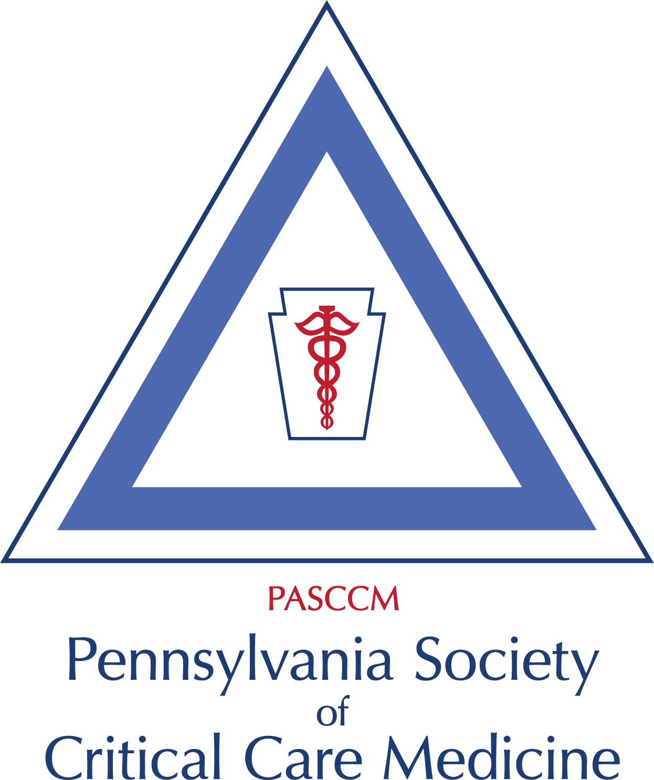
PA Chapter SCCM Executive Board:
President: Lori Demko MSN RN CCRN ACNP-BC
Past President: Navitha Ramesh, MD, FCCP
President Elect: Joshua Marks, MD, FACS, FCCM
Secretary: Amanda Holyk, PharmD, BCCCP
Treasurer: Barbara Birriel, PhD, ACNP-BC, FCCM
PA Med Society Rep: Herb Patrick, MD, FCCM

Regional Reps & Committee Chairs:
SE Rep: Dan Wu, DO, FACOS, FACS, FCCM
NE Rep: Jonathan Goldner, DO, FCCM
West Rep: Janine Then, Pharm D, BC
Mandi Krach AGACNP-BC
Central Rep: Michelle Daryanani, DO
Communications: Rich Arbour, RN, MSN, FCCM
Education: Joshua Marks, MD FACS,FCCM
Brenda Engler DNP, ACNP-BC, CCRN
Membership: 4 Regional reps

Pennsylvania Chapter of the Society of Critical Care Medicine
SCCM Winter Business Meeting (Virtual)
Wednesday, February 7, 2024 @3:30 pm
Minutes

- Meeting called to order by Lori Demko @1531.
- Attendees present: Lori demko, John Madara, Barb Birriel, Navitha Ramesh, Sandy Blossner, Janine Then, Josh Marks, Niels Martin, Dan Wu, Brenda Engler, Rich Arbour, Amanda Holyk
- No leadership introductions- no new members present.
- A motion to approve the Minutes from 11/13/23 was made by Niels Martin and seconded by Barb Birriel.
- President’s Report (Lori Demko) -
- 2024 Annual Operational Report to be submitted/filed by LD by 3/31/24
- Updated Chapter Officer List submitted to national & up to date on website
- Chapter Officer Transition List sent out to board (obtained from Chapter Alliance):
- Discussion: The annual operational report can be submitted by the president or past president of the chapter. The E postcard should submitted by treasurer (Barb Birriel) by 3/15. Lori will update the bylaws to reflect this (previously was May 15th). Barb will send the E postcard to Lori to submit with annual chapter report. President elect (Josh Marks) will be added back to executive board list on the meeting agenda template.
- SCCM Congress Travel Stipend to President/Officers: The chapter determined that the president (or approved alternate) submit a letter of request to chapter leadership for approval. Eligible items for financial support include conference registration, transportation, and hotel nights for the dates of congress. President may decline travel support if not needed. If the president is unable to attend, this stipend opportunity can be considered for another officer to ensure chapter presence. An expense report should be submitted to the treasure after annual congress. Motion to approve was made by Lori Demko, and seconded by John Madara.
- Annual Challenges Conference 8/16/24
- 2024 Dr’s Joseph & Rae Brown Award - Niels Martin received. Nominations accepted for 2025 due by 8/1/24. The chapter will look for nominee opportunities for this year’s award cycle.
- First ever PA Chapter SCCM Booth at Congress 2024 - SCCM provided to chapter at no cost, staffed by chapter, save the date flyers and In training grant flyers distributed at booth, next year provide candy, ? chapter merchandise, challenges conference registration giveaway- For next year, priority for a booth will go to the Florida chapter. If they decline, other chapters may have the opportunity to reserve a booth. Per a Chapter Alliance update provided by Dan Wu, there may be an area on the exhibit floor designated for the chapters in the future.
- PA Chapter Congress Reception- There were 25 attendees at the reception.
- Chapter Alliance Status Report submitted by LD for meeting 9/12/23
- Chapter Alliance Meeting Update (Dan Wu) – Dan provided updates on the future chapter area in the exhibit hall at congress (see above) and the required conflict of interest form for chapter officers. Criteria for the best chapter award was also discussed. This includes chapter growth, innovation, activites, and multidisciplinary representation.
4. Past President’s Report (Navitha Ramesh) - Navitha would like to do another chapter funded FCCS or ultrasound course. Amanda will send results of the previous interest survey to Lori and Navitha to help guide next steps.
5. Secretary’s Report (Amanda Holyk) - Annual Business Meeting Report/Minutes 8/2024, Chapter meeting minutes recorded from 11/13/24 meeting – Minutes approved as noted above.
6. Treasurer’s Report (Barb Birriel) - Budget & Financial Statement:
- Balance: Barb reported a balance of $85,563.65
- Income review
- Expenses
- File e-Post card IRS Form 990-N by 5/15, recommended to be filed by 3/15 and State Tax Return- Barb will send to Lori to submit with the annual report.
- Joseph & Rae Brown Award ($1000) - August 1 Nomination Deadline - to be reviewed and determined - . There has not been a request for the Brown award from SCCM so Barb will check with SCCM to make sure we aren’t behind. Lori noted she never got an invoice for the logo revision either.
- Drinker Critical Care Society (Philadelphia) Sponsorship $500 annually in September- Barb informed the group the Drinker Society invoice was still oustanding. Niels will send that to Barb for both 2023 and 2024.
7. Education Committee (Josh Marks & Brenda Engler)
- In training grant: Rich will send out information/reminders monthly on the 15th until the deadline. Josh will email Dominika to ask for this master list of sponsored fellows/in training in PA, although unclear if this list is accessible. Information will also will be communicated through SCCM connect so all chapter members get notified.
- FCCS courses: Brenda is a course consultant for most of the FCCS courses and Rich and Dan are instructors. Lori will consider a small group committee to further delve into the logistics/details of this.
8. Communication Committee (Rich Arbour). SCCM Connect & Twitter for meeting reminders and updates. Newsletter via Connections
- See above regarding In training grant.
9. Membership Committee - PA Chapter SCCM members
- Comprised of Regional Reps. Look for opportunities to promote dinner, networking events, webinars. Advertise chapter.
SE Rep: Dan Wu, DO, FACOS, FACS, FCCM
NE Rep: Johnathon Goldner, DO, FCCM
West Rep: Janine Then, Pharm D: Mandi Krach, MSN RN AGACNP-BC
Central Rep: Michelle Daryanani, DO
10. PA Medical Society Update (Herb Patrick): no update
11. Old Business: Lori will contact Angela Slampak from Geisinger about pursuing a joint venture webinar between the clinical pharmacology section and the chapter.
12. Open Forum/New Business
13. Next Meeting – April 17th @330pm.
14. Adjourn : The meeting was adjourned at 1629.

Respectfully Submitted,

Amanda Holyk, PharmD, BCCCP
Secretary, PA Chapter SCCM

