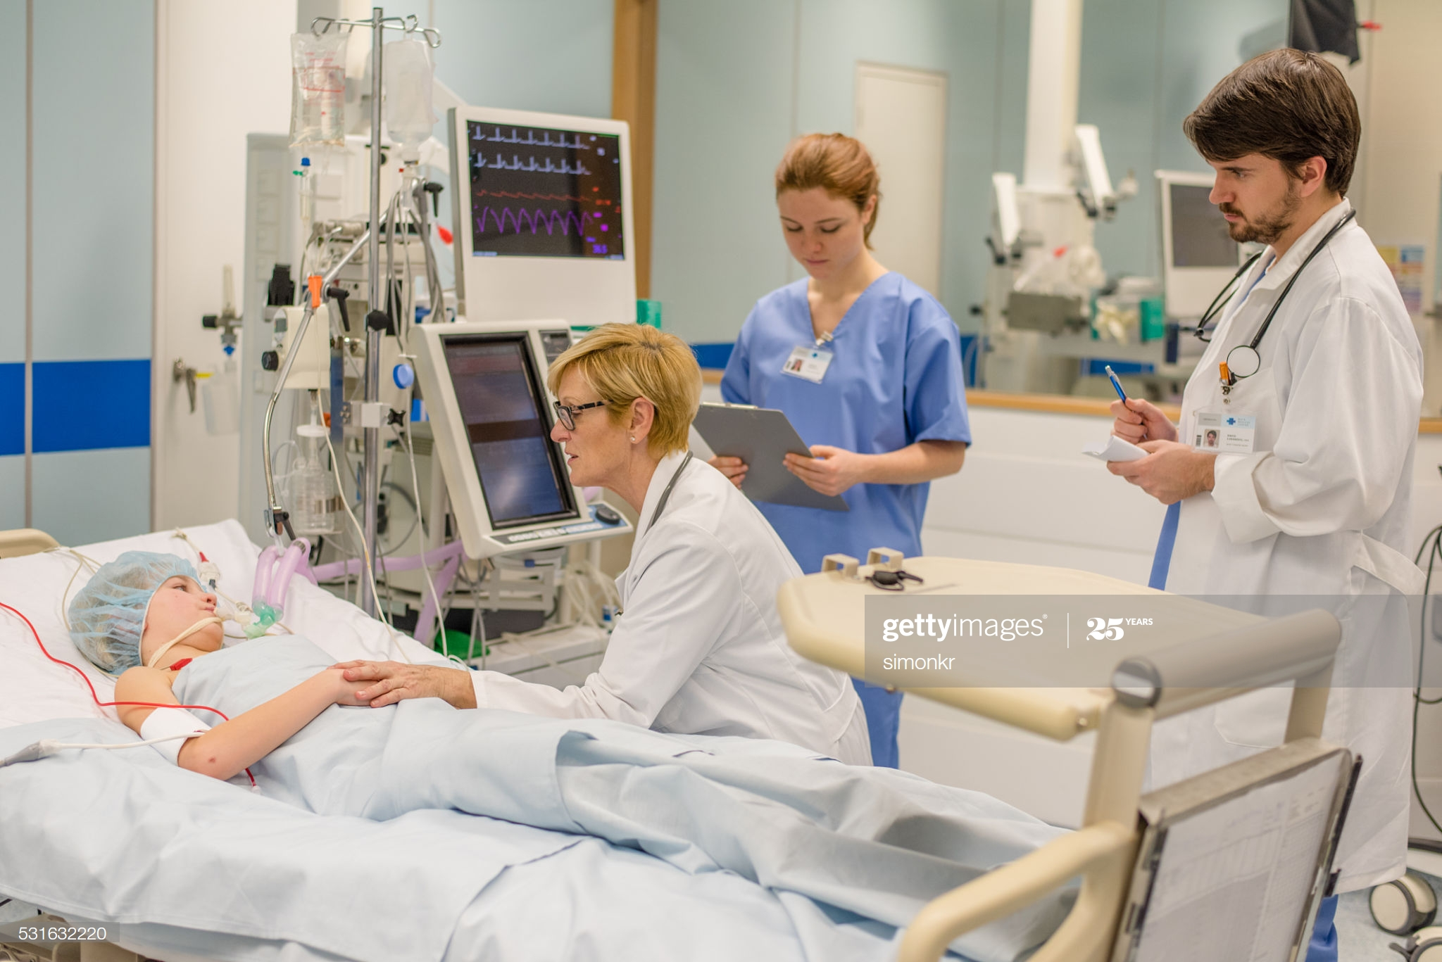  - June 6, 2023@6pm  Scientific Meeting of the Delaware society of critical care medicine Attend online with Zoom at https://bit.ly/41Iz9eV  The Delaware Society of Critical Care Medicine is a local chapter of the Society of Critical Care Medicine. This meeting will focus on 2 Plenary talks: Normothermic Regional Perfusion and Sepsis and Fluids.  Zoom Details:  Topic: DE Chapter SCCM  Time: June 6th 06:00PM – 07:00PM Eastern Time (US and Canada)  Join Zoom Meeting  DE SCCM June 6 ZOOM Link  Meeting ID: 848 7950 4848 | Agenda:  Welcome  Bethany Melo, PAC  President DE SCCM Chapter  Speaker Introduction  Laura Toulson, ACNP and Maureen Seckel, ACNS  Plenary Talks:  Normothermic Regional Perfusion – what is it and why is it problematic?  Richard Choi, MD  Sepsis and Fluids  Andrew Deitchman, MD  Delaware SCCM Chapter  President: Bethany Melo, PAC  President-elect: Laura Toulson, ACNP  Past President: Farid Moosavy, MD  Secretary: Jamie Rosini, PharmD  Treasurer: Sandra Vernon, RN  