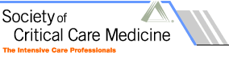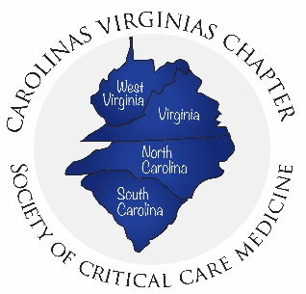

Carolinas/Virginias Chapter of the Society of Critical Care Medicine (CVCSCCM)
Membership Committee

Mission

To maintain membership data and foster chapter recruitment/retention in collaboration with the Communications Committee, other CVCSCCM Committees, and SCCM.

Charges

- Communicate with SCCM and SCCM Connect page administrators
  - Navigate the new online platform for membership management
  - Work closely with SCCM to determine new members, expiring memberships, and membership data

- Maintain membership data
  - Keep track of membership statistics (disciplines, state/location, and institutions represented by the current membership)
  - Reach out to the membership to welcome new members and send closing surveys for feedback from members who depart from the chapter

- Recruitment/retention
  - Plan membership recruitment/retention activities
  - Analyze closing survey results
  - Help identify institution liaisons (in conjunction with the CVCSCCM Communications Committee)

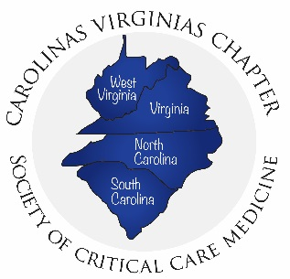

Carolinas/Virginias Chapter of the Society of Critical Care Medicine (CVCSCCM)
Membership Committee

Mission

To actively recruit and maintain members of the Carolinas/Virginias Chapter of SCCM.

Charges

- Membership Maintenance
  - Maintain accurate contact list for all current members
  - Communicate directly with SCCM national representatives regarding membership dues

- Membership Recruitment and Retention
  - Plan recruitment activities
  - Follow-up communications with lapsed members

- Membership Spotlight
  - Highlight new/existing members in the chapter communications periodically

