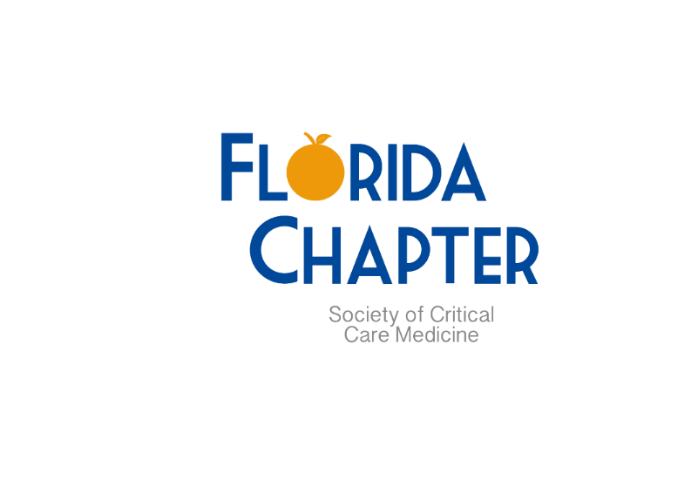

Scholarship in Progress Webinar Series

Tuesday November 8th, 2022 at 2pm EST via Zoom

**LINK:** <https://us02web.zoom.us/j/85001363262?pwd=QVdkRExDNnRFMGhLakEyVHB1eFE5UT09>

**Meeting ID:** 850 0136 3262

**Passcode:** 123456

**Presenters:**

|  |  |
| --- | --- |
| **Anjali Garg, MD**  Fellow, Pediatric Critical Care Medicine      **Topic:**  “Clinical Outcomes Variation in Relation to the Childhood Opportunity Index” | **Mohammad Dlewati, DO**  Resident, Internal Medicine    **Topic:**  “Intrapleural Fibrinolytic Therapy to Enhance Chemical Pleurodesis“ |

If you or a trainee you know may know are interested in presenting in this format, please apply via our [ONLINE APPLICATION](https://forms.gle/3Api36T5PrhE7m1v5)

Cheers,



Anthony A. Sochet, MD, MSc

Immediate Past President, SCCM Florida Chapter

Assistant Professor, Anesthesiology and Critical Care Medicine

Johns Hopkins University School of Medicine | Johns Hopkins All Children’s Hospital  
[Anthony.Sochet@jhmi.edu](mailto:Anthony.Sochet@jhmi.edu)