SCCM FLORIDA CHAPTER
2024 ELECTIONS

PRESIDENT-ELECT NOMINEE

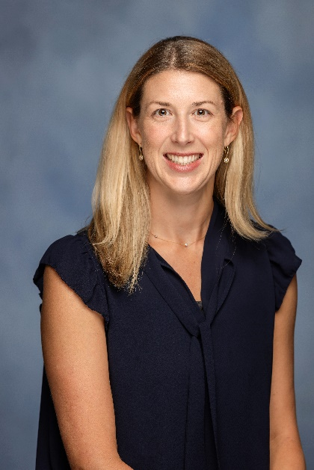

Kaitlin Alexander, PharmD
Kaitlin Alexander is a Clinical Associate Professor in the University of Florida Department of Pharmacotherapy and Translational Research. Dr. Alexander joined the University of Florida faculty in May 2021 and maintains a clinical practice in the trauma intensive care unit at UF Health Shands Hospital in Gainesville, Florida. Dr. Alexander graduated from the University of Florida with her Doctor of Pharmacy degree. She then completed a PGY-1 Pharmacy Practice Residency at West Virginia University Healthcare, followed by a PGY-2 Residency specializing in critical care at Wake Forest Baptist Medical Center.
Dr. Alexander has demonstrated dedication and commitment to the Florida Chapter of the Society of Critical Care Medicine (SCCM), having recently held the position of Secretary. She is committed to enhancing the educational offerings and fostering a sense of community and connection among members. Her ultimate goals are to facilitate the continued growth of the Chapter and enhance its organization and productivity.
SECRETARY NOMINEE
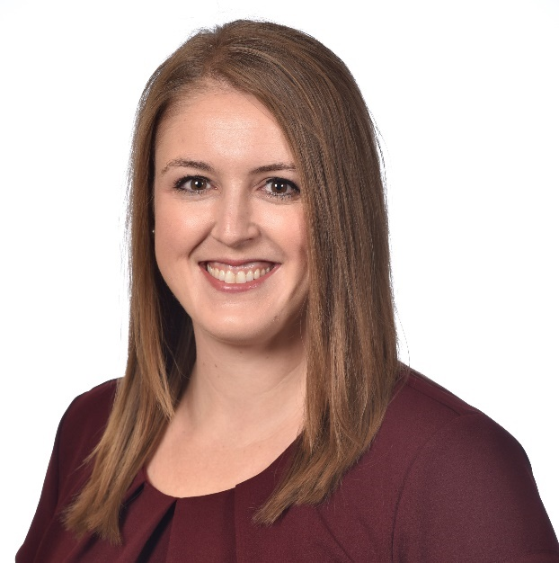

Sydney McNeill, PharmD, BCCCP
Sydney McNeill, PharmD, BCCCP is a Critical Care Medicine Clinical Pharmacy Specialist at Orlando Health – Orlando Regional Medical Center in Orlando, Florida. She received her Bachelor of Science and Doctor of Pharmacy degree from the University of Tennessee in 2020. She then completed a PGY1 and PGY2 Critical Care Pharmacy Residency at Orlando Regional Medical Center.
Dr. McNeill is an active member in the Society of Critical Care Medicine with involvement in the Clinical Pharmacy and Pharmacology section and the Florida Chapter. She served on the 2023 Florida Chapter SCCM Annual Symposium planning committee where she was the chair for the abstract committee and continues that role this year. She is also involved with the Florida Society of Health-System Pharmacists where she has served as the CE Coordinator and is currently serving as the President-Elect for the Central Florida Regional Chapter. Her critical care interest areas include sepsis, alcohol withdrawal, infectious diseases, and sedation practices.

SECRETARY NOMINEE
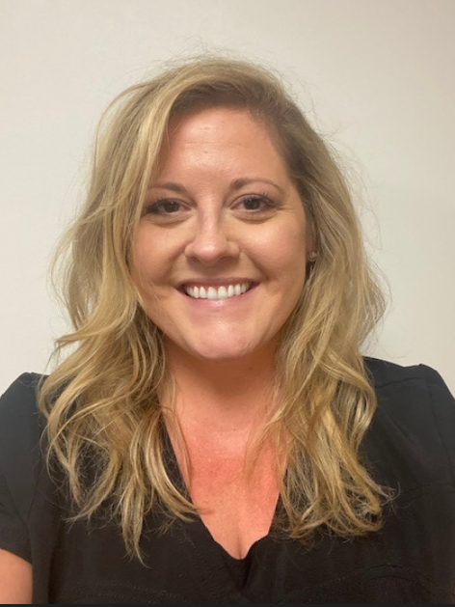

Whitney Gibson Medford, Pharm D, BCCCP
Whitney Medford is an accomplished Critical Care Pharmacist with a passion for delirium, targeted temperature management, adrenal insufficiency in critical illness, and management of pain and sedation. With a diverse background including a Bachelor of Science in psychology and experience in corporate retirement banking prior to starting her career in medicine, she brings a unique perspective to critical care medicine.
Dr. Medford completed her PharmD at Wingate University School of Pharmacy in Wingate, North Carolina, her PGY1 residency at Detroit Medical Center in Detroit, Michigan, and her PGY2 residency at Tampa General Hospital in Tampa, Florida. She now works as a Critical Care Pharmacist in the BayCare Health System Virtual ICU in Saint Petersburg, Florida.
With an unwavering commitment to excellence, interdisciplinary collaboration, and a focus on evidence-based medicine and continuous learning, she continues to strive to make significant contributions to the area of Critical Care.
Dr. Medford has served on the Florida Chapter Board of Directors and has enjoyed helping with Chapter decisions, development of the new website, and building the Chapter Twitter page. Transitioning to the role of Chapter Secretary would an honor and a new challenge that would be welcomed and exciting!

BOARD OF DIRECTORS NOMINEE
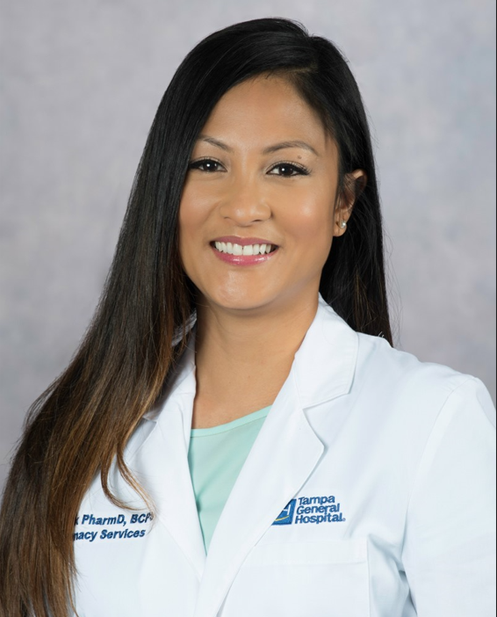

Czarina Bock, PharmD, BCPS, BCCCP, CACP

Dr. Czarina Bock went to University of South Florida for her undergraduate studies and received her Doctor of Pharmacy degree from Nova Southeastern University in 2009. She then completed an ASHP-accredited pharmacy practice residency at Bay Pines Veterans Affairs Medical Center in Bay Pines, FL. She joined the clinical pharmacy staff at Tampa General Hospital in 2010. Dr. Bock has experience covering a variety of patient population and areas including the IV room and supervisor role. She transitioned to her current role in 2015 and continues to work as the cardiac critical care pharmacist. She serves as the Assistant-RPD for the PGY1 Pharmacy Residency Program and precepts interns and residents in the area of cardiac ICU. She actively participates in scholarly activities such as research and teaching and involved in various organizational task force and committees. Dr. Bock’s professional service activities include membership in Anticoagulation Forum, American College of Clinical Pharmacy and Society of Critical Care Medicine.

BOARD OF DIRECTORS NOMINEE
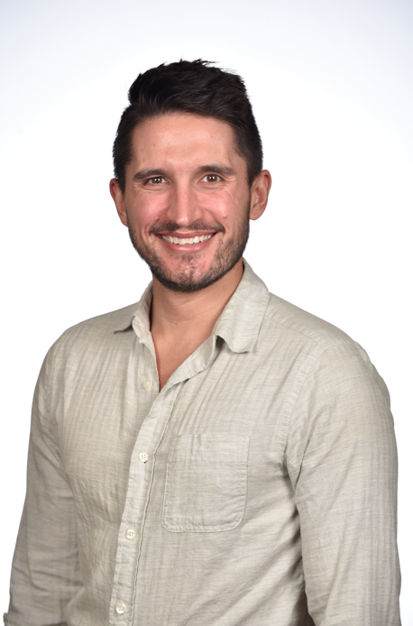

Chancey Carothers, PharmD, BCCCP
Chancey Carothers is a Clinical Pharmacy Specialist at Orlando Health- Orlando Regional Medical Center (ORMC), and he practices primarily in the Cardiovascular ICU. He obtained his PharmD from East Tennessee State University in 2014, going on to complete a PGY-1 Pharmacy Practice Residency and a PGY-2 Critical Care Pharmacy Residency at ORMC in 2015 and 2016, respectively. He has served as the ORMC Residency Coordinator for the last two years and is the incoming PGY-1 Pharmacy Practice Residency Program Director with the incoming 2024-2025 class.
Dr. Carothers has been involved with SCCM since 2015 and has served in various committee roles in the Clinical Pharmacy and Pharmacology Section on both the Education and Research and Scholarship committees. Additionally, he has served in various roles for the Florida Chapter of SCCM, having been involved in the Membership committee, serving on the planning committee for the 2023 Annual Symposium, and serving as the current Regional Coordinator for the East Central Region. He looks forward to continuing to interdisciplinary collaboration across the state with the goal of increasing professional growth, research and scholarship, and ultimately patient care in the state of Florida.

BOARD OF DIRECTORS NOMINEE
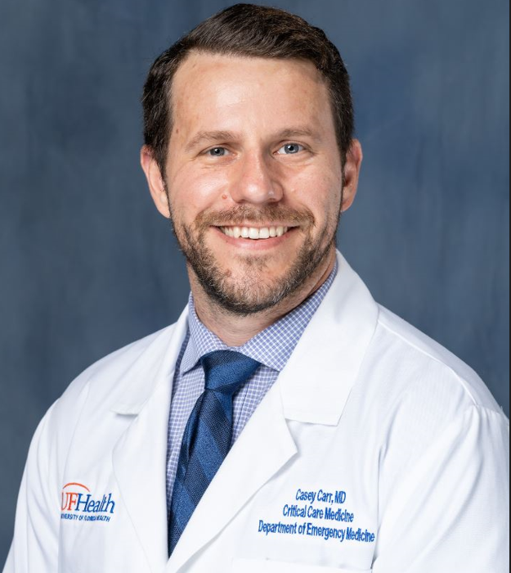

Casey Carr, MD
Dr. Carr is an intensivist at the University of Florida, where he has practiced for the past 3 years, primarily in the cardiac ICU. He completed residency training at Johns Hopkins and critical care medicine fellowship at University of Florida. His academic interests are in cardiac arrest and ECLS. Outside of medicine, Dr. Carr loves spending time with family, reading, and running (very slowly).

BOARD OF DIRECTORS NOMINEE
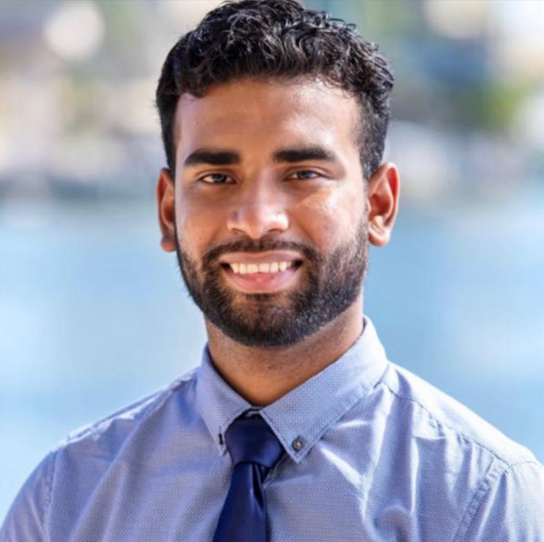
David Ragoonanan, PharmD, BCCCP
Dr. Ragoonanan completed his PGY1 residency at Ascension St. Vincent’s in Jacksonville, Florida and his PGY2 residency in Critical Care at Tampa General Hospital. Since then, David has obtained critical care board certification and continues to participate in meaningful research. He currently works as the Trauma pharmaceutical care specialist at Sarasota Memorial Hospital. In this role, he serves as the clinical pharmacist for the Trauma ICU and Trauma step down units. He has been involved with SCCM for years as a member and presented research at multiple SCCM Conferences. He aims to further his involvement by serving as Board of Directors for Florida Chapter.

BOARD OF DIRECTORS NOMINEE
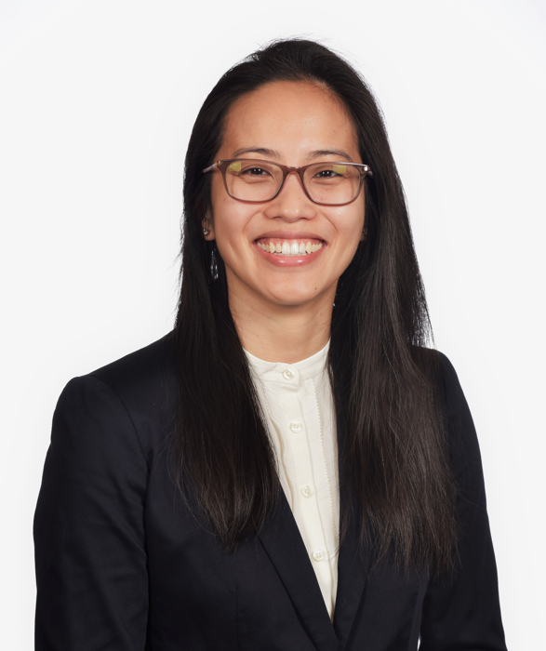

Mai Vo, MD
Dr. Vo currently serves as Orlando Health – Orlando Regional Medical Center’s Medical Director of Critical Care Medicine and Associate Program Director of Orlando Health’s Critical Care Medicine Fellowship Program. From a national level, she serves on the SCCM Post Graduate and Fellowship Education Committee and Item Writing Committee and has great interest and passion to enhance critical care medicine education at home in Orlando, statewide and nationally. The opportunity to serve on the board would allow for her to learn what other critical care medicine leaders are doing within their local community to share with other regions as well as demonstrating the innovative ideas were bringing out in Orlando. This will create a synergistic environment of ideas and educational processes to communicate with one another to elevate our state’s critical care medicine clinicians into the future.

