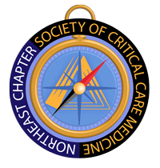
2020 SCCM Northeast Chapter Clinical Congress Scholarship

On behalf of SCCM Northeast Chapter,
We would like to congratulate Mr. Ash Seth, PA-C, MBA, FCCM as the 2020 SCCM Northeast Chapter Clinical Congress Scholarship winner.
The Northeast Chapter Steering Committee has chosen you as receiver of the scholarship based on your dedication and commitment to critical care medicine.
We would like to ask you to please provide a short letter after this year’s Congress and describe your experience. With your permission, we would like to post this short letter on our SCCM-Northeast Website.
Congratulations again and look forward to seeing you in Orlando, where you will receive the scholarship at our business meeting. Any questions, please don’t hesitate to contact us.
Sincerely,
Northeast Chapter Steering Committee
James Lunn, President

