Hands-on Critical Care: | 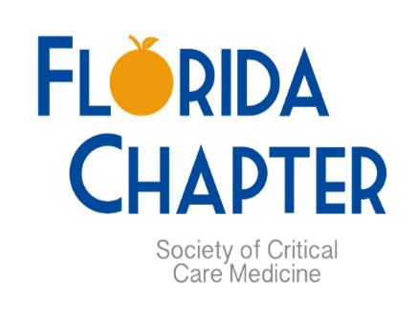
Taking action at the bedside
Date: |  | Time: |  |  |  | Location:
10/21/23 |  | 7:30 AM – 5:00 PM |  |  |  | Renaissance Orlando at Sea World
Registration: |  |  |  | KEYNOTE Speaker :
https://bit.ly/FLChapterAnnualSymposium  Early bird pricing ends Sept. 1st! |  |  |  | Dr. Jose Pascual, MD, PhD, FRCS(C), FACS, FCCM, incoming SCCM Secretary on  TBI Care in the ICU

Networking
Please join us at the hotel the night before for a FREE social networking event.
Room block: https://book.passkey.com/go/SCCMFloridaChapter

Friday, October 20th, 2023 at 7:00 PM
Renaissance Orlando at Sea World
6677 Sea Harbor Dr, Orlando, FL 32821

Abstract Submission
Deadline to submit abstracts: August 4th
Abstracts are still encouraged even if presenting at another conference (such as SCCM Congress, etc.)
Free registration for Star Research Presenters

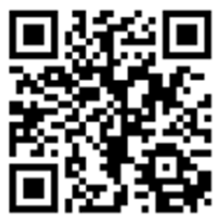

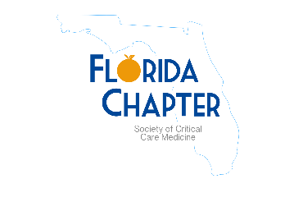
Society of Critical Care Medicine Florida Chapter
Annual Symposium
Saturday, October 21, 2023

Registration
7:30 am  7:30 am – 8:00 am | Registration Opens  Breakfast

Hands-On Critical Care: Taking Action at the Bedside
8:00 am – 8:15 am | Welcome and Opening Session  Speaker: Bob Cambridge, DO, MPH, FCCM
8:15 am – 9:15 am | Keynote Address (1h CE)  TBI care in the ICU  Speaker: Jose Pascual, MD, PhD, FRCS(C), FACS, FCCM
9: 15 am – 10:00 am | Bedside Ultrasound in the ICU (0.75h CE)  Speaker: David Bostick, MD
10:00 am – 10:30 am | Break / Exhibits
10:30 am – 11:00 am | Utilization of TEG in Critically Ill Patients (0.5h CE)  Speaker: James Priano, PharmD, BCPS, BCEMP
11:00 am – 12:00 pm | Telemedicine in the ICU: A multidisciplinary panel discussion (1h CE)  Speaker: Whitney Gibson, PharmD, BCCCP, Robert Stein, MD, and  Kerri Blaney, RN
12:00 pm – 1:00 pm | Lunch / Exhibits / “Bring an App to Share” Networking Session
1:00 pm – 1:45 pm | STAR Research Snapshot Presentations (3 @ 15min each) (0.75h CE)
1:45 pm – 2:30 pm | Poster Rounds / Exhibits
2:30 pm – 3:30 pm | Brain Death in FL (1h CE)  Speakers: Amay Parikh, MD, MBA, MS, and Bobby Nibhanipudy, MD
3:30 pm – 3:45 pm | Break / Exhibits
3:45 – 4:15 pm | Critical Care Beyond the ICU (0.5h CE)  Speaker: Radhames Ramos De Oleo, MD, MPH, MBA, FACP
4:15 – 4:45 pm | Stop the Bleed (non-CE accredited)  Speaker: Marcia Johansson, DNP, ACNP-BC, FCCM, FAANP
4:45 – 5:00 pm | Awards, Wrap Up and Closing Remarks  Speaker: Bob Cambridge, DO, MPH, FCCM
https://bit.ly/FLChapterAnnualSymposium

