CHOI Pediatric Critical Care Presents:

2nd Annual Pediatric Critical Care Conference
Extracorporeal Therapies and E - CPR

October 17, 2023
Featured Speakers

Dr. Ryan Morgan Dr. Jill Cholette

Attending Physician Chief of the Division of Critical Care

Pediatric Intensive Care Unit University of Rochester
Children's Hospital of Philadelphia Golisano Children's Hospital

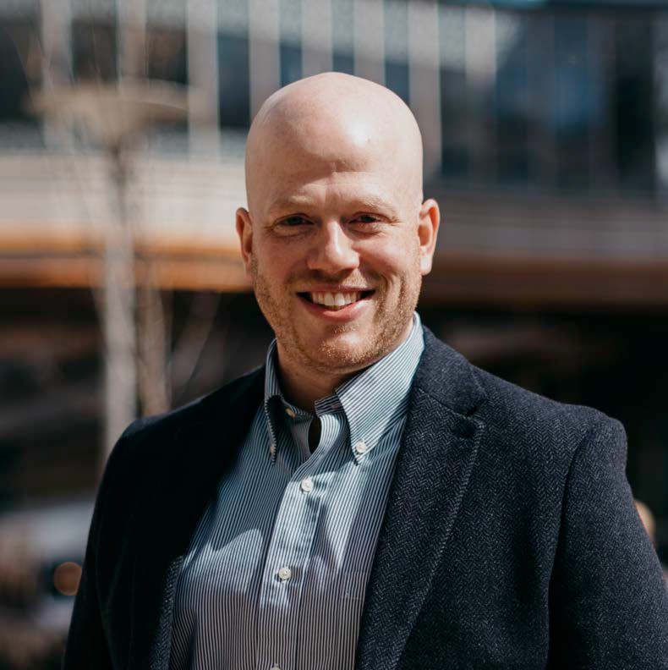
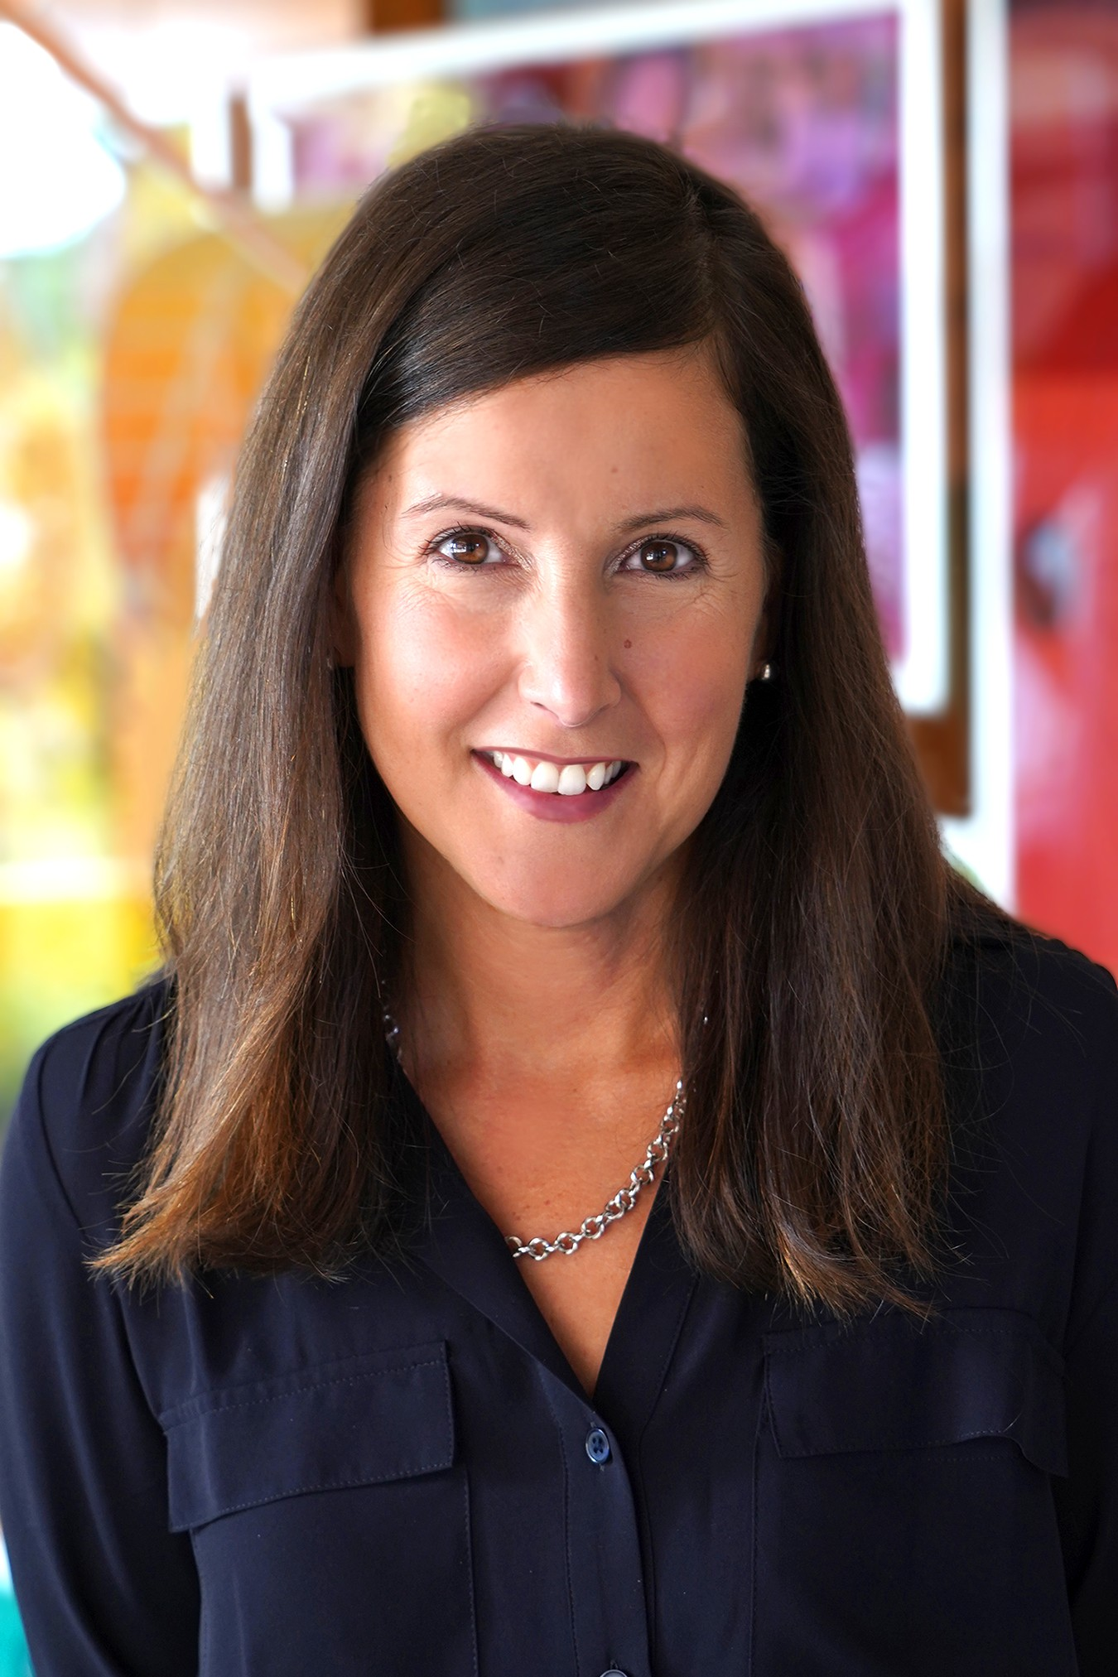

To Register:

No Registration Fee

This program will be provided virtually as well

Once registered, the webinar link will be sent to you via email one week prior to the event

A light breakfast and lunch is provided with refreshments throughout the day

University of Illinois College of Medicine at Peoria will provide CME/CEU (Anticipated 6.25 hours)

PROGRAM (Central Time Zone)

09:00 - 09:15 Welcome, Introduction, Housekeeping Remarks
Syngal Prachi MD

09:15 - 10:00 Keynote Address
CPR in the PICU: Leveraging Physiology to Design Tomorrow's Resuscitation Strategies
Ryan Morgan MD, MTR

10:00 - 10:45 Keynote Address
Bleeding Management and Transfusion Strategies in Congenital Cardiac Surgery
Jill Cholette MD

10:45 - 11:00 Break

11:00 - 11:45 Lecture

ECMO Cannulation: Techniques and Challenges
Mark Plunkett MD

11:45 - 12:30 Lecture
Anticoagulation During Pediatric Extracorporeal Membrane Oxygenation: Funambulism at its Finest
Michael Tarantino MD

12:30 - 13:00 Lunch
13:00 - 13:45 Lecture

13:45 - 14:45

ECLS Case Studies
Jessica Blanton, CCP & Angela Farnan RN

Panel Discussion and Q&A
Moderator: Prachi Syngal, MD

Panelists: Drs. Morgan, Cholette, Plunkett, Tarantino and Jessica Blanton,CCP; Angela Farnan, RN

14:45 - 15:45 Simulation

15:45 - 16:00 Evaluation

ECMO Simulator Sessions
Jessica Blanton and Angela Farnan

SPEAKERS

RYAN MORGAN MD, MTR
Medical education at Binghamton University of New York New York University School of Medicine
University of Pennsylvania Perelman School of Medicine Fellowship Pediatric Critical Care Medicine, Children's Hospital of Philadelphia, University of Pennsylvania School of Medicine Assistant Professor of Pediatrics, University of Pennsylvania School of Medicine
Assistant Professor of Anesthesiology and Critical Care at the Children's Hospital of Philadelphia
Attending Physician, Pediatric Intensive Care Unit, Children's Hospital of Philadelphia

JILL CHOLETTE, MD
Completed medical education at University of Rochester including Internal-Medicine Residency
Pediatric Critical Care Fellowship Pediatric Cardiology Fellowship
Double boarded in Pediatric Critical Care & Cardiology Chief of the Division of Critical Care at University of Rochester
Golisano Children's Hospital
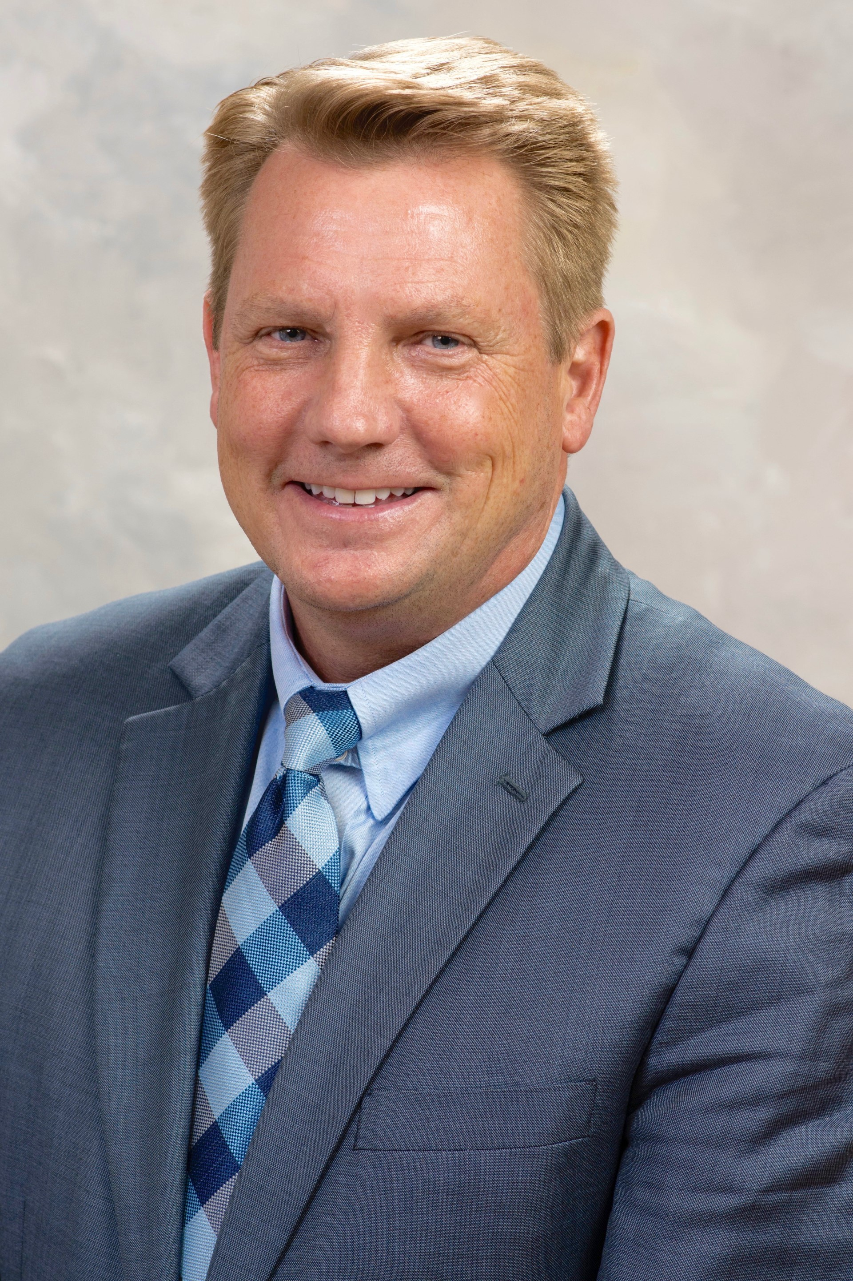
Medical Director of the Pediatric Intensive Care Unit Medical Director of the Critical Care Transport Team

MARK DAVID PLUNKETT, M.D.
Medical Education at Duke University and University of North Carolina, Chapel Hill
Surgical training in General and Cardiothoracic Surgery at Duke University, Medical Center
Board certified by the American Board of Cardiothoracic Surgery Chief, Pediatric and Congenital Heart Surgery at OSFHealthcare Children's Hospital of Illinois
Co-Director, Congenital Heart Center OSF HealthCare Children's Hospital of Illinois
Associate Clinical Professor of Surgery
University of Illinois College of Medicine

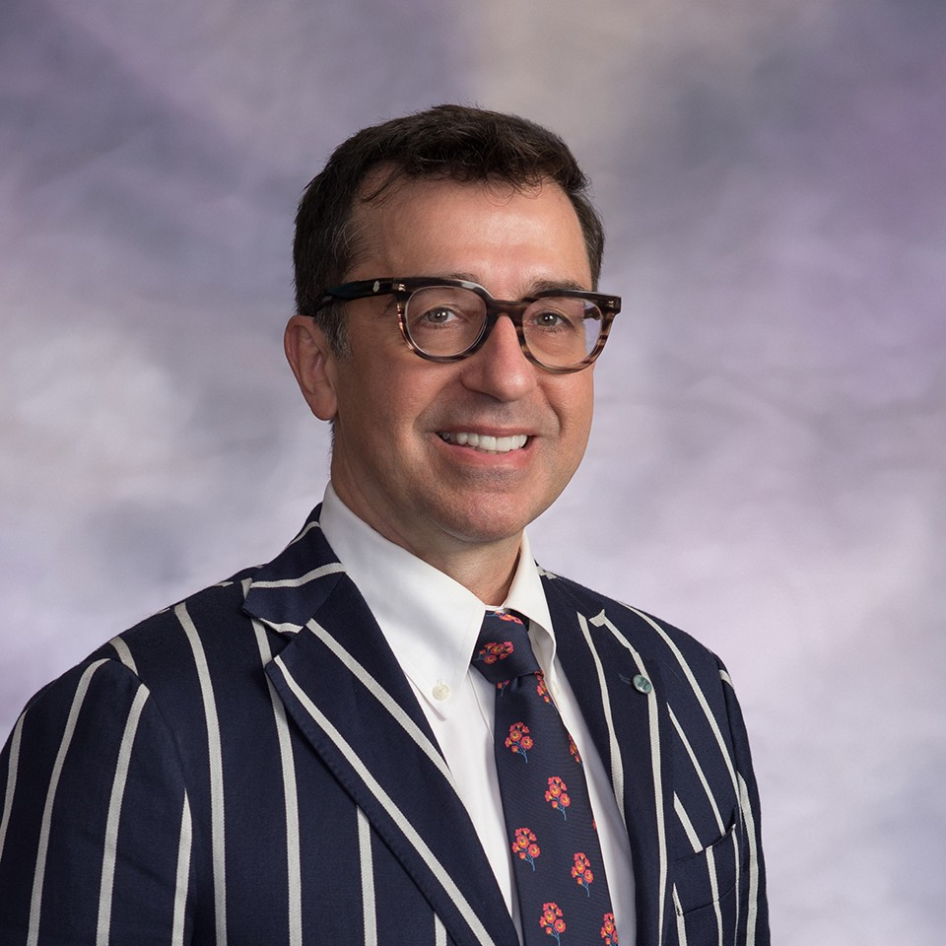
Michael Tarantino MD
Medical education at University of Wisconsin School of Medicine and Public Health
Fellowship in Pediatric Hematology & Oncology at University of Wisconsin
Board Certified in Pediatric Hematology & Oncology Medical Director of the Anticoagulation Constultation at OSF Healthcare St. Francis Medical Center
Professor of Pediatrics and Medicine at University of Illinois College of Medicine, Peoria
Founder, CEO & CMO of the Bleeding & Clotting Disorders Institute in Peoria, Illinois

