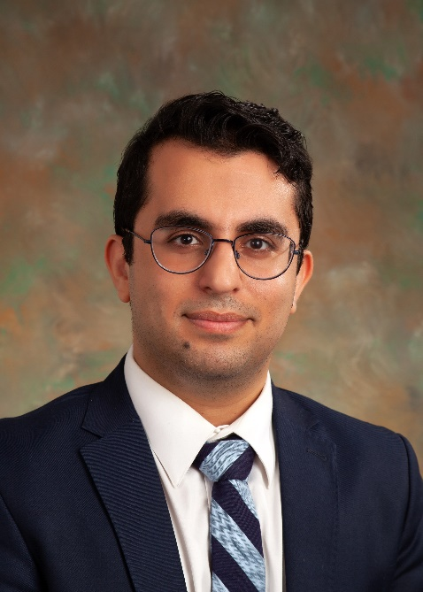
Critical Care Virtual Webinar
SCCM Midwest Chapter

Wednesday, December 7, 2023 at 6:00pm CDT

A brief overview of Acute Respiratory Distress Syndrome for critical care providers

Presented by: Seyedmohammad Pourshahid, MD, MPH

Dr. Seyedmohammad (Omid) Pourshahid, is an assistant professor of Clinical Thoracic Medicine and Surgery at the Lewis Katz School of Medicine at Temple University. He completed an Internal Medicine residency in the Mount Sinai program at Queen's hospital, followed by pulmonary and critical care fellowship at Virginia Tech Carilion School of Medicine. He concentrated his public health studies on behavioral health promotion. Dr. Pourshahid, currently serves as the medical director of pulmonary rehabilitation at Temple Hospital main campus in Philadelphia, PA. He has many publications and received grant support for his research in pulmonary rehabilitation.

Objectives
- Review the evolution of ARDS definition over time highlighting new (2023) global definition
- Pathophysiology, common causes and prevalence of ARDS
- An evidence-based overview of what needs to be done when caring for patients with ARDS, with focus HFNC, fine tuning the ventilator settings, fluid management, steroids, proning and ECMO
This webinar is offered free of charge to those that attend

The Zoom link will be sent after you register prior to the webinar
To register: https://www.sccmmwc.org/event-registration/

This program is approved for 1 hour of CME/CEU per University of Illinois College of Medicine at Peoria

