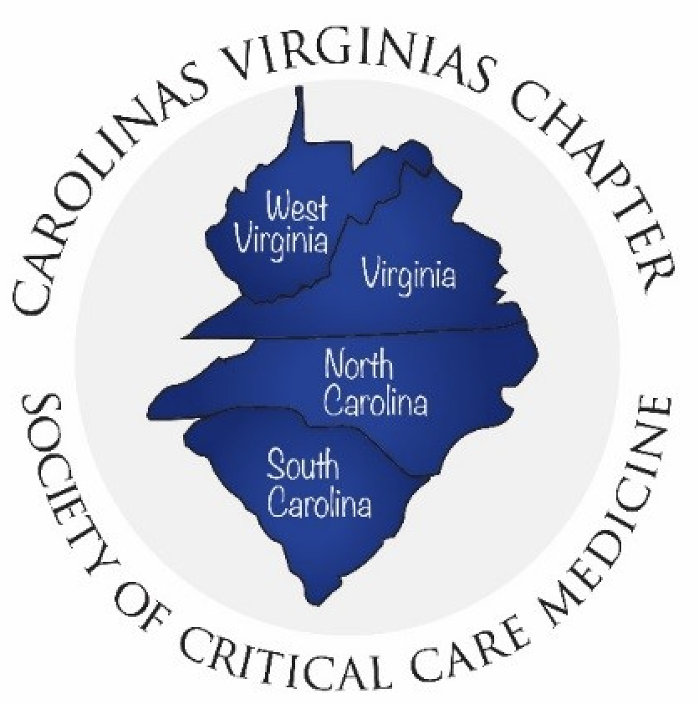SYMPOSIUM SCHOLARSHIP APPLICATION

We would like everyone who is interested in attending the Carolinas Virginias Chapter Society of Critical Care Medicine Annual Symposium to join us. Please answer the following questions for scholarship consideration:

- Why are you interested in attending the CVCSCCM 39th Annual Symposium?

- What do you plan to do with this information?

- Which sessions would you like to attend? (Circle or highlight)

  - Pre-Conference Only (June 17, 2021)

  - Symposium Only (June 18, 2021)

  - Both days (June 17 & 18, 2021)

Applications are due June 1st with notifications to follow shortly thereafter. Email application to Amanda Edwards amedwards@wakemed.org

