Society of Critical Care Medicine,
Florida Chapter
Est. 2017

President
Anthony Sochet, MD, MSc, FAAP
anthony.sochet@jhmi.edu
President-Elect
Carinda J. Feild, PharmD , FCCM
cfeild@cop.ufl.edu
Immediate Past President
Jennifer Montero, PharmD, BCPS, BCCCP
jennifer.montero@mylrh.org
Secretary
Michael Semanco, PharmD, BCPS, BCCCP
michael.semanco@mylrh.org
Treasurer
Israel Villanueva, MD MBA
Israel.villanueva.jr.md@gmail.com

Welcome Letter

Dear Current or Future Member,
Welcome to the Society of Critical Care Medicine (SCCM), Florida Chapter. The Florida Chapter is a multidisciplinary group of critical care practitioners promoting collaboration among fellow healthcare providers and leaders. The Chapter provides an opportunity to network with local practitioners, to develop leadership skills, to discuss the impact of national issues within local communities, and to develop and improve clinical skills through educational opportunities.
The Florida Chapter was founded in the Tampa Bay area in 2016 and was officially approved by SCCM in May 2017. It is currently one of 17 approved chapters throughout the country. Current members include physicians, pharmacists, nurses, advanced practice providers (APPs), respiratory therapists, dieticians, and physical therapists demonstrating the true multidisciplinary nature of the chapter. The chapter leadership consists of an elected Board of Directors including a President, President-Elect, Immediate Past-President, Treasurer, and Secretary. Currently, there are five committees (Annual Symposium Planning, Education, Fundraising/Marketing, Membership, and Nominating) charged with promoting the growth and development of the chapter and its members in various capacities. Additionally, there is a State Regional Coordinator who oversees our state’s eight regions, each of which has a designated regional liaison.
For additional information concerning the chapter or how to become involved, please contact a member of the Board of Directors or a Committee Chair. We look forward to collaborating with you in the future!
Best Regards,
Board of Directors
Society of Critical Care Medicine, Florida Chapter

Committees

Annual Symposium Planning Committee
The Annual Planning Committee is responsible for coordinating all aspects as it relates to the Annual Symposium. The committee is chaired by a nominee approved by the chapter’s Board of Directors and will include, at minimum, one member from each of the standing committees. The committee will meet quarterly and as needed via a conference call throughout the year. The Annual Symposium takes place in October. The charges for the committee include planning and booking of the venue, identification and coordination of speakers and educational activities, coordination and booking of vendors, coordination of CE for all disciplines, marketing, and registration. This committee is an excellent way to get involved and participate in multi-committee and interprofessional interactions. If you are interested in getting involved in this committee, please contact Maresa Glass, PharmD, BCCCP, FCCM (mglass@tgh.org).

Education Committee
The Education Committee is primarily responsible for planning critical care educational opportunities for the Florida chapter, maintaining a list of provided education including vendor sponsorship, and assisting with planning educational events for the Annual Symposium. The committee will conduct frequent surveys to gain member input on timing and content of education opportunities. Based on the survey results, the committee will plan educational events every two to four months at local venues. Additionally, the committee coordinator coordinates the chapter’s alternating monthly schedule of educational webinars and Scholarship in Progress webinars. When possible, continuing education credits will be provided. These education opportunities serve as a platform to interact with each other in a learning environment and to strengthen our local chapter. If you have an interest in getting involved with this committee, please contact Ramos De Oleo Radhames, MD, MPH, MBA, FACP (radhamesramose73@gmail.com)

Fundraising/Marketing Committee
The Fundraising/Marketing Committee is primarily responsible for disseminating information regarding the chapter’s education and networking events. The committee will also organize events to raise funds to assist the chapter in future educational and research opportunities. The Fundraising/Marketing Committee will work in conjunction with the Membership and Education committees to enhance membership and event participation. Additionally, the committee will develop and maintain a social media presence on Facebook and other possible social media venues. If you are interested in getting involved in this committee, please contact Marlena Fox, PharmD, BCPS, BCCCP (marlena.fox@orlandohealth.com).

Membership Committee
The Membership Committee is primarily responsible for welcoming new members and promoting membership involvement. The committee will assist in recruiting new members, retaining current members, providing information regarding the chapter and committees, and collaborating with the Education and Marketing Committees to promote upcoming activities. This committee also works closely with the State Regional Coordinator to facilitate membership growth among the regions. We continue to develop new and innovative ideas to promote the Florida Chapter. If you have an interest in getting involved with this committee, please contact AnnMarie Morrisseau, DNP, APRN, ACNP-BC (ammorrisseau@gmail.com).

Nominating Committee
The Nominating Committee is primarily responsible for organizing the annual chapter elections. Prior to the annual business meeting at SCCM Congress, the committee will consider all nominations, make additional nominations as appropriate, and ultimately recommend at least 2 candidates for each open position to the chapter members for election. This committee must be compromised of at least three chapter members, none of whom are currently serving on the Board of Directors and is chaired by the chapter’s Immediate Past-President. If you have an interest in getting involved with this committee, please contact Jennifer Montero, PharmD, BCPS, BCCCP (jennifer.montero@mylfh.org).

State Regions
The primary focus of the Regional Coordinators is to promote membership in the 8 Florida Chapter regions while maintaining a cohesive focus for the chapter as a whole. This includes engaging membership within each region in educational and networking events. The Florida chapter regions include the following: Panhandle, Suwannee River, St. John’s River, East Central, West Central, Treasure Coast, Gulf Coast, and Broward/Dade. If you have an interest in getting involved, please contact the State Regional Coordinator, Rebecca Rich, PharmD, BCPS, BCCCP, FCCM (rebecca.rich@mylrh.org).
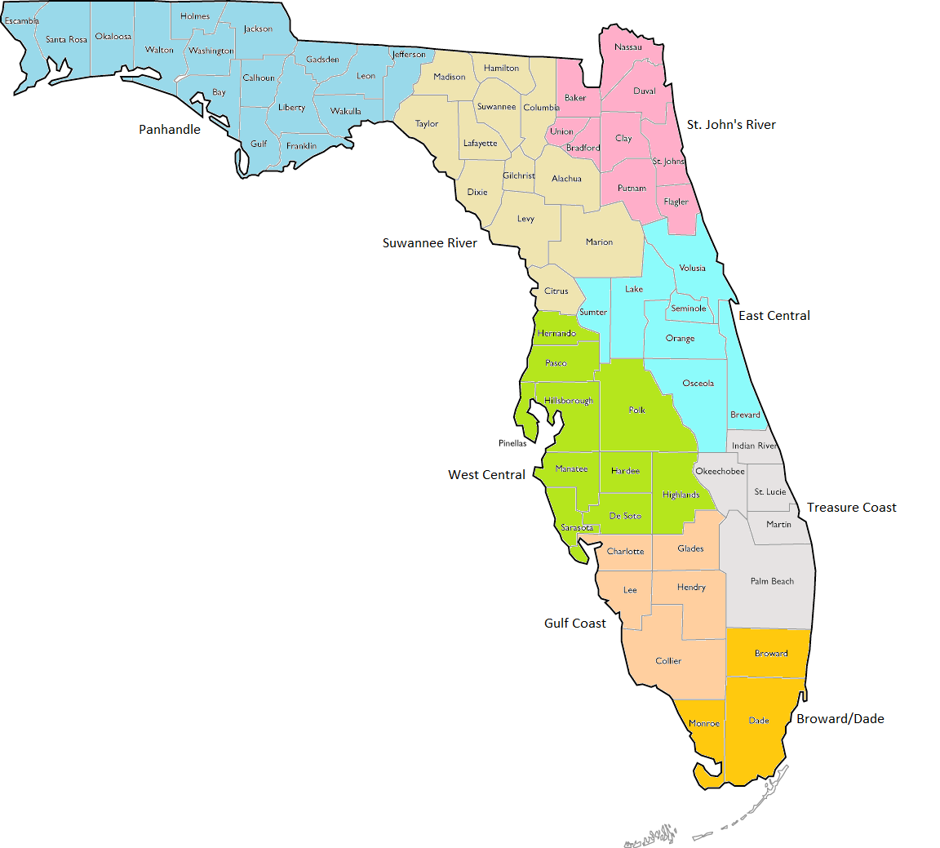

How to Join
- Please visit https://sccm.org/Member-Center/Chapters/Florida.
- If you are not an SCCM member but want to join the Florida Chapter, complete the following:
  - SCCM Chapter Membership Application: select Florida chapter
  - Pay the $45 Chapter Dues. We highly encourage all FL Chapter members to be involved in national SCCM!
- If you are an SCCM member and want to join the Florida Chapter, complete the following:
  - Application and pay Chapter Dues as described above: select Florida chapter
  - Pay the Chapter Dues of $45 with your yearly SCCM membership renewal
- For any questions, please contact us via email at FLChapterSCCM@gmail.com or find us on Facebook - (@FLChapterSCCM)

