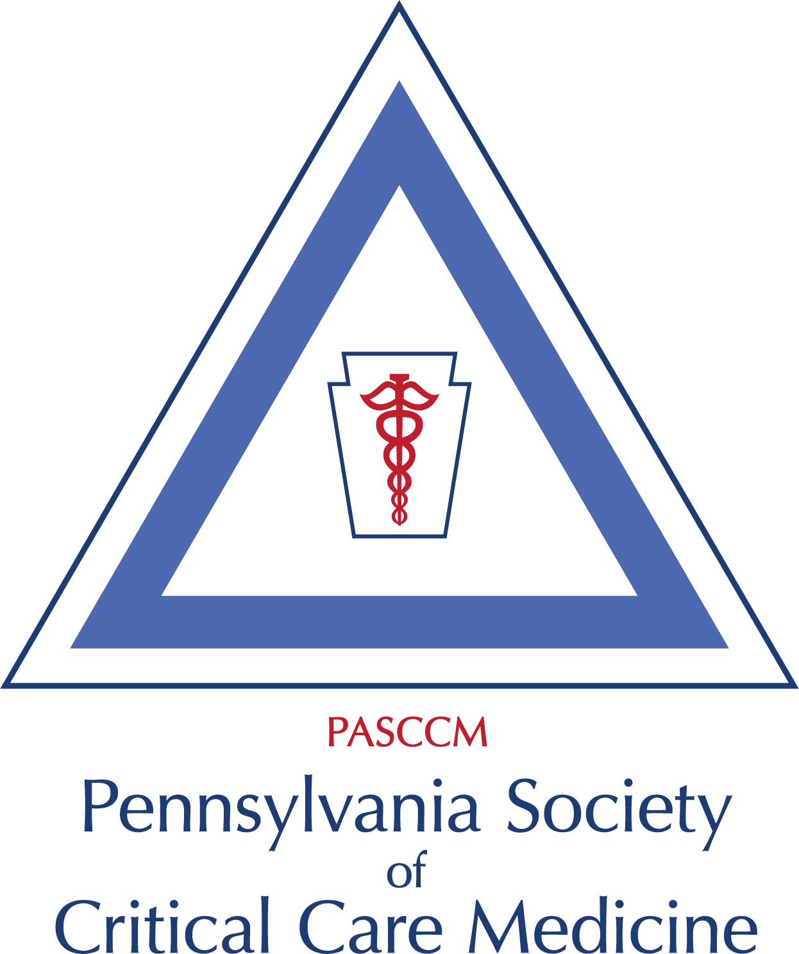
PA Chapter SCCM Executive Board:
President: Lori Demko MSN RN CCRN ACNP-BC
Past President: Navitha Ramesh, MD, FCCP
President Elect: Joshua Marks, MD,FACS,FCCM
Secretary: Amanda Holyk, PharmD, BCCCP
Treasurer: Barbara Birriel, PhD, ACNP-BC, FCCM
PA Med Society Rep: Herb Patrick, MD, FCCM

Regional Reps & Committee Chairs:
SE Rep: Dan Wu, DO, FACOS, FACS, FCCM
NE Rep: Jonathan Goldner, DO, FCCM
West Rep: Janine Then, Pharm D, BC
Mandi Krach AGACNP-BC
Central Rep: Michelle Daryanani, DO
Communications: Rich Arbour, RN, MSN, FCCM
Education: Joshua Marks, MD FACS,FCCM
Brenda Engler DNP, ACNP-BC, CCRN
Membership: 4 Regional reps

Pennsylvania Chapter of the Society of Critical Care Medicine
SCCM Quarterly Business Meeting (Virtual)
Wednesday, April 17, 2024 @3:30 pm
Agenda

1. Call to Order
2. Introduction of Chapter Leadership
3. Review and Approval of Minutes 2/7/24
4. President’s Report (Lori Demko)
- 2023 Annual Operational Report submitted to Chapter Alliance and copy sent to PA Chapter Executive Board by LD by 3/18/24 (Due 3/31)
- Annual Challenges Conference 8/16/24
- 2024 Dr’s Joseph & Rae Brown Award - Nominations being accepted for 2025 due by 8/1/24
- LD contacted Angela Slampack PharmD at Geisinger per request on 2/19 about joint venture webinar between clinical pharmacology section and the chapter -Awaiting to hear back
- Chapter Alliance Meeting Update 2/27 last meeting - Dan
4. Past President’s Report - Navitha Ramesh Chapter Funded FCCS or U/S Course – Review of previous intrest survey
5. Secretary’s Report - Amanda Holyk
6. Treasurer’s Report - Budget & Financial Statement - Barb Birriel
- Balance
- Income review
- Expenses – Chapter Logo revision invoice 1/31/24 $75.00
- File e-Post card IRS Form 990-N by 5/15, recommended to be filed by 3/15 and State Tax Return
- Joseph & Rae Brown Award ($1000) - August 1 Nomination Deadline - to be reviewed and determined (Chapter has not received request from SCCM as of yet)
- Drinker Critical Care Society (Philadelphia) Sponsorship $500 annually in September (? If Niels sent Barb invoices for 2023 & 2024)
7. Education Committee - Josh Marks & Brenda Engler
- In training grant – deadline for submission 6/15, LD sent message on SCCM connect on 2/15, Rich to advertise on the 15th of each month till deadline
- ? FCCS Course – consider small group committee.
8. Communication Committee - Rich Arbour. SCCM Connect & Twitter for meeting reminders and updates. Newsletter via Connections
9. Membership Committee - PA Chapter SCCM members
- Comprised of Regional Reps. Look for opportunities to promote dinner, networking events, webinars. Advertise chapter.
SE Rep: Dan Wu, DO, FACOS, FACS, FCCM
NE Rep: Johnathon Goldner, DO, FCCM
West Rep: Janine Then, Pharm D: Mandi Krach, MSN RN AGACNP-BC
Central Rep: Michelle Daryanani, DO
10. PA Medical Society Update (Herb Patrick)
11. Old Business
12. Open Forum/New Business
13. Next Meeting – TBD
14. Adjourn

