Julie Polisiakiewicz DO
I hope this outline is helpful, please see my works cited for where I obtained this information. I’m including some bullet points at the beginning for what I think are the most important or novel ideas. Hope this helps!
This was last updated 3/16/20

- SARS-CoV-2 is the virus and COVID-19 (coronavirus disease 2019) is the disease (8) - this is similar to HIV/AIDS
- Based on the current epidemiological survey, the latency period is generally from 3 to 7 days, with a maximum of 14 days (12)
- Recent reports of high titers of virus in the oropharynx early in the course of disease arouse concern about increased infectivity during the period of minimal symptoms.(6)
- (51%) patients had chronic diseases, including cardiovascular and cerebrovascular diseases, endocrine system disease, digestive system disease, respiratory system disease, malignant tumour, and nervous system disease (4)
- The most common symptoms were fever (43.8% on admission and 88.7% during hospitalization)(2)
- One study also observed a median duration of viral RNA detection of 20.0 days (IQR 17.0–24.0) in survivors, but COVID-19 virus was detectable until death in non-survivors. The longest observed duration of viral shedding in survivors was 37 days (10)
- Evolving evidence to say that ACE I may WORSEN this disease, also keep in mind NSAIDs and thiazolidinediones may theoretically worsen it
  - ACE2 has been identified as a functional receptor for coronaviruses, including SARS-CoV and SARS-CoV-2 (15)
- Although the clinical manifestations of COVID-19 are dominated by respiratory symptoms, some patients have severe cardiovascular damage (15)
- No radiographic or CT abnormality was found in 157 of 877 patients (17.9%) with nonsevere disease and in 5 of 173 patients (2.9%) with severe disease(2)
- the most common patterns on chest CT were ground-glass opacity (56.4%) and bilateral patchy shadowing (51.8%) (2)
- Lymphocytopenia was present in 83.2% of the patients on admission.(2)
- CO-Infection
  - Other Viruses 0 (4)
  - Bacteria 1% (4)
  - Fungus 4% (4)
- Patients with SARI should be treated cautiously with intravenous fluids
- Steroids - probably NO! - for the long answer see below!
- Remdesivir - INVESTIGATIONAL treatment

Severe Acute Respiratory Syndrome Coronavirus- 2 (SARS-CoV-2)

- novel enveloped RNA betacoronavirus that has currently been named severe acute respiratory syndrome coronavirus 2 (SARS-CoV-2) (2), (12)
- It has an envelope (12)
- Its particles are round or oval, often polymorphic, with a diameter from 60 nm to 140 nm (12)
- No evidence of viral mutation has been found so far (12)
- Coronaviruses are a large family of viruses that are common in people and many different species of animals, including camels, cattle, cats, and bats.(1)
- SARS-CoV-2 is the virus and COVID-19 (coronavirus disease 2019) is the disease (8) - this is similar to HIV/AIDS
- Compared with the SARS-CoV that caused an outbreak of SARS in 2003, SARS-CoV-2 has a stronger transmission capacity. (15)

Mortality Rate
- The case fatality rate is about 2-3 percent (8), (9) but still evolving

How does it work?
- Most viruses enter cells through receptor-mediated endocytosis. The receptor that 2019-nCoV uses to infect lung cells might be ACE2, a cell-surface protein on cells in the kidney, blood vessels, heart, and, importantly, lung AT2 alveolar epithelial cells (3), (16)
  - These AT2 cells are particularly prone to viral infection (3)
- One of the known regulators of endocytosis is the AP2-associated protein kinase 1 (AAK1) (3)
- Disruption of AAK1 might, in turn, interrupt the passage of the virus into cells and also the intracellular assembly of virus particles (3)
- The reduced susceptibility of females to viral infections could be attributed to the protection from X chromosome and sex hormones, which play an important role in innate and adaptive immunity. (4)

Transmission
- Because SARS-CoV-2 can be detected in the gastrointestinal tract, saliva, and urine, these routes of potential transmission need to be investigated (2)
- Based on the current epidemiological survey, the latency period is generally from 3 to 7 days, with a maximum of 14 days (12)
- Unlike SARSr-CoV, 2019-nCoV is contagious during the latency period (12)
- Virus particles spread through the respiratory mucosa and infect other cells, induce a cytokine storm in the body, generate a series of immune responses, and cause changes in peripheral white blood cells and immune cells such as lymphocytes (4)
- One study indicates an estimated basic reproduction number (R0) of 2.2, which means that, on average, each infected person spreads the infection to an additional two persons (6)
  - until this number falls below 1.0, it is likely that the outbreak will continue to spread (6)
- Recent reports of high titers of virus in the oropharynx early in the course of disease arouse concern about increased infectivity during the period of minimal symptoms.(6)
- Higher viral loads were detected soon after symptom onset, with higher viral loads detected in the nose than in the throat (7)
- Analysis suggests that the viral nucleic acid shedding pattern of patients infected with SARS-CoV-2 resembles that of patients with influenza and appears different from that seen in patients infected with SARS-CoV (7)
- The viral load that was detected in the asymptomatic patient was similar to that in the symptomatic patients, which suggests the transmission potential of asymptomatic or minimally symptomatic patients (7)
  - These findings are in concordance with reports that transmission may occur early in the course of infection and suggest that case detection and isolation may require strategies different from those required for the control of SARS-CoV (7).

Demographics
- Patients with severe disease were older than those with nonsevere disease by a median of 7 years. (2)
- more likely to affect older males with comorbidities (4)
  - with an overall median age of 57.0 years (17)
- the presence of any coexisting illness was more common among patients with severe disease than among those with nonsevere disease (38.7% vs. 21.0%) (2)
  - exposure history between the two groups of disease severity was similar(2)
- Compromised respiratory status on admission (the primary driver of disease severity) was associated with worse outcomes (2)
- (51%) patients had chronic diseases, including cardiovascular and cerebrovascular diseases, endocrine system disease, digestive system disease, respiratory system disease, malignant tumour, and nervous system disease (4)
  - Cardiovascular and cerebrovascular diseases (40%) (4)
  - Digestive system disease (11%) (4)
  - Endocrine system disease (13% (4) - mostly diabetes
  - Malignant tumour, Nervous system disease, Respiratory system disease (1%) (4)
- 0.9% of the patients were younger than 15 years of age(2)

Special Populations
- Pregnant People
  - There is currently no known difference between the clinical manifestations of COVID-19 pregnant and non-pregnant people or individuals of reproductive age (10)
  - To date, there are limited data on clinical presentation and perinatal outcomes after COVID-19 during pregnancy or the puerperium. There is no evidence that pregnant individuals present with different signs or symptoms or are at higher risk of severe illness. So far, there is no evidence on ‘mother’-to-child transmission when infection manifests in the third trimester, based on negative samples from amniotic fluid, cord blood, vaginal discharge, neonatal throat swabs or breastmilk. Similarly, evidence of increased severe maternal or neonatal outcomes is uncertain, and limited to infection in the third trimester, with some cases of premature rupture of membranes, fetal distress, and preterm birth reported (10)
- Breast Feeding
  - As with all confirmed or suspected COVID-19 cases, symptomatic individuals who are breastfeeding or practising skin-to-skin contact or kangaroo mother care should practise respiratory hygiene, including during feeding (for example, use of a medical mask when near a child if the mother has respiratory symptoms), perform hand hygiene before and after contact with the child, and routinely clean and disinfect surfaces with which the symptomatic mother has been in contact. (10)
  - Breastfeeding counselling, basic psychosocial support, and practical feeding support should be provided to all pregnant individuals and individuals with infants and young children, whether they or their infants and young children have suspected or confirmed COVID-19. (10)
- The elderly and immunosuppressed may present with atypical symptoms (10)
- Old age, obesity, and presence of comorbidity might be associated with increased mortality (4)
- Among the overall population, 23.7% had at least one coexisting illness (e.g., hypertension and chronic obstructive pulmonary disease) (2)
- Diabetics
  - The expression of ACE2 is substantially increased in patients with type 1 or type 2 diabetes, who are treated with ACE inhibitors and angiotensin II type-I receptor blockers (ARBs).(16)
- Asthmatics and COPD Patients
  - In one study from Wuhan - Chronic obstructive pulmonary disease (COPD, 1.4%) patients and current smokers (1.4%) were rare (17)
    - Allergic diseases, asthma, and COPD are not risk factors for SARS-CoV-2 infection (17)
  - Should these people still be using their steroid inhalers? GOOD question! I haven’t found any data to support them not using it but if anyone reading this finds some please let me know! (jnm160@gmail.com)

Testing
- Collect specimens from the upper respiratory tract (URT; nasopharyngeal and oropharyngeal) AND, where clinical suspicion remains and URT specimens are negative, collect specimens from the lower respiratory tract when readily available (LRT; expectorated sputum, endotracheal aspirate, or bronchoalveolar lavage in ventilated patient) for COVID- 19 virus testing by RT-PCR and bacterial stains/cultures. (10)
  - When collecting URT samples, use viral swabs (sterile Dacron or rayon, not cotton) and viral transport media. Do not sample the nostrils or tonsils. In a patient with suspected COVID-19, especially with pneumonia or severe illness, a single URT sample does not exclude the diagnosis, and additional URT and LRT samples are recommended. LRT (vs URT) samples are more likely to be positive and for a longer period (10)
- Sputum induction should be avoided owing to increased risk of aerosol transmission. (10)
- COVID-19 testing of symptomatic pregnant individuals may need to be prioritized to enable access to specialized care (10)
- In hospitalized patients with confirmed COVID-19, repeated URT and LRT samples can be collected to demonstrate viral clearance. The frequency of specimen collection will depend on local epidemic characteristics and resources. For hospital discharge, in a clinically recovered patient, two negative tests, at least 24 hours apart, is recommended. (10)
- The low absolute value of lymphocytes could be used as a reference index in the diagnosis of new coronavirus infections in the clinic (4)

Clinical Characteristics

- The median age of the patients was 47 years(2)
- 41.9% of the patients were female(2)
- The most common symptoms were fever (43.8% on admission and 88.7% during hospitalization)(2)
- cough (67.8% - 82%)(2), (4)
- shortness of breath (31%) (4)
- muscle ache (11%) (4)
- confusion (9%) (4)
- headache (8%) (4)
- sore throat (5%) (4)
- rhinorrhoea (4%) (4)
- chest pain (2%) (4)
- Diarrhea was uncommon (3.8%)(2)
- More than one sign or symptom (89%) (4)
- Fever, cough, and shortness of breath (15%) (4)

Clinical Course
- The median incubation period was 4 days (interquartile range, 2 to 7)(2)
- (17%) with ARDS (4)
- (8%) with acute respiratory injury(4)
- (3%) with acute renal injury (4)
- (4%) with septic shock (4)
- (1%) with ventilator-associated pneumonia (4)
- the currently reported case fatality rate is approximately 2%.4 In another article in the Journal, Guan et al. report mortality of 1.4% (6)
- Some reports suggest worsening during the second week of illness (9)
- higher Sequential Organ Failure Assessment (SOFA) score and d-dimer > 1 μg/L on admission were associated with higher mortality (10)
- One study also observed a median duration of viral RNA detection of 20.0 days (IQR 17.0–24.0) in survivors, but COVID-19 virus was detectable until death in non-survivors. The longest observed duration of viral shedding in survivors was 37 days (10)
- Of those critically ill, most will require mechanical ventilation (10)
- The most common diagnosis in severe COVID-19 patients is severe pneumonia. (10)
- The median duration from symptom onset to discharge or death were 22.1 (IQR 17--28) and 17.7 (IQR, 13--23) days respectively (13)
- The death group were more commonly to have complications of Acute Respiratory Distress Syndrome(ARDS), acute cardiac injury, acute coagulopathy, acute kidney injury and shock compared with the discharged group (P<0.001, all) (13)
- The identified independent risk factors (elevated TnT, CRP, and D-dimer, and declined PaO2/FiO2) suggest that fatality due to COVID-19 was associated with multiple organ dysfunction. (13)
Cardiac Involvement
- Although the clinical manifestations of COVID-19 are dominated by respiratory symptoms, some patients have severe cardiovascular damage (15)
- Angiotensin-converting enzyme 2 (ACE2) is a membrane- bound aminopeptidase that has a vital role in the cardio- vascular and immune systems (15)
- ACE2 is involved in heart function and the development of hypertension and diabetes mellitus(15)
- ACE2 has been identified as a functional receptor for coronaviruses, including SARS-CoV and SARS-CoV-2 (15)
- SARS-CoV-2 infection is triggered by binding of the spike protein of the virus to ACE2, which is highly expressed in the heart and lungs (15)
- SARS-CoV-2 mainly invades alveolar epithelial cells, resulting in respiratory symptoms (15)
- These symptoms are more severe in patients with CVD, which might be associated with increased secretion of ACE2 in these patients compared with healthy individuals (15)
- Given that ACE2 is a functional receptor for SARS-CoV-2, the safety and potential effects of antihypertension therapy with ACE inhibitors or angiotensin-receptor blockers in patients with COVID-19 should be carefully considered (15)
  - Whether patients with COVID-19 and hypertension who are taking an ACE inhibitor or angiotensin-receptor blocker should switch to another antihypertensive drug remains controversial, and further evidence is required (15). -CONSIDER STOPPING A PATIENT’S ACE I
- Myocardial injury associated with the SARS-CoV-2 occurred in 5 of the first 41 patients diagnosed with COVID-19 in Wuhan, which mainly manifested as an increase in high-sensitivity cardiac troponin I (hs-cTnI) levels (>28 pg/ml) (15)
- The levels of biomarkers of myocardial injury were significantly higher in patients treated in the ICU than in those not treated in the ICU (median creatine kinase (CK)-MB level 18 U/l versus 14 U/l, P < 0.001; hs-cTnI level 11.0 pg/ml versus 5.1 pg/ml, P = 0.004), suggesting that patients with severe symptoms often have compli- cations involving acute myocardial injury (15)
- Among the people who died from COVID-19 reported by the National Health Commission of China (NHC), 11.8% of patients without underlying CVD had substantial heart damage, with elevated levels of cTnI or cardiac arrest during hospitalization (15)
- Fulminant myocarditis is a rare clinical syndrome with features of cardiac inflammation and a reported high mortality rate of approximately 40–70% (14)
  - FM can be categorized into the histologically defined entities of lymphocytic, eosinophilic, and giant cell myocarditis and sarcoid heart disease (14)
  - The lymphocytic forms are subdivided into those of infective and noninfective origin(14)
  - Whereas viral etiology is assumed but not proven in the majority of cases, biopsy studies of patients with acute myocarditis in Europe indicate that viral etiology ranges between 37.8% and 77.4% (14)
  - In patients with severe heart failure (ejection fraction [EF] < 45%) and inflammation in the Marburg registry, 42.1% were virus positive (14)
  - The mortality rate of FM ranges from 40 to 70% in most centers(14)
    - The current Chinese publication on “Life support-based comprehensive treatment regimen” demonstrated a mortality rate of less than 5% (14)
    - This treatment regimen included the early application of sufficient doses of immune-modulation drugs, e.g., sufficient doses of steroids and i.v. immunoglobins, neuraminidase inhibitors, and active mechanical life-support treatments(14)
  - The condition of some patients with severe SARS-CoV‑2 infection patients might deteriorate rapidly with acute respiratory distress syndrome and septic shock, which is eventually followed by multiple organ failure and fulminant myocarditis (14)
  - More attention should be paid to patients with extremely increased cardiac troponin I (cTnI) levels and new-onset arrhythmias(14)
  - The application of mechanical respirators and circulatory support systems, including IABP, Impella, and ECMO, might have beneficial effects on these patients (14)

Radiographic Findings
- No radiographic or CT abnormality was found in 157 of 877 patients (17.9%) with nonsevere disease and in 5 of 173 patients (2.9%) with severe disease(2)
- the most common patterns on chest CT were ground-glass opacity (56.4%) and bilateral patchy shadowing (51.8%) (2)
- (75%) bilateral pneumonia - CXR or CT (4)
- (14%) multiple mottling and ground-glass opacity - CXR or CT (4)
- (1%) pneumothorax (4)
- According to chest x-ray and CT (75%) patients showed bilateral pneumonia (75%) with just (25%) patients showing unilateral pneumonia (4)
- CT imaging characteristics:
  - (1) dominant distribution (mainly subpleural, along the bronchial vascular bundles) (12)
  - (2) quantity (often more than three or more lesions, occasional single or double lesions)(12)
  - (3) shape (patchy, large block, nodular, lumpy, honeycomb-like or grid-like, cord-like, etc.)(12)
  - (4) density (mostly uneven, a paving stones-like change mixed with ground glass density and interlobular septal thickening, consolidation and thickened bronchial wall, etc.)(12)
  - (5) concomitant signs vary (air-bronchogram, rare pleural effusion and mediastinal lymph nodes enlargement, etc.)(12)
- The CT imaging demonstrates 5 stages according to the time of onset and the response of body to the virus, including:(12)
  - Ultra-early stage.
    - This stage usually refers to the stage of patients without clinical manifestation, negative laboratory test but positive throat swab for 2019-nCoV within 1–2 weeks after being exposed to a virus-contaminated environment (history of contact with a patient or patient-related family members, unit, or medical staff in a cluster environment). (12)
    - The main imaging manifestations are single, double or scattered focal ground-glass opacity, nodules located in central lobule surrounded by patchy ground-glass opacities, patchy consolidation and sign of intra-bronchial air-bronchogram, which was dominant in the middle and lower pleura (12)
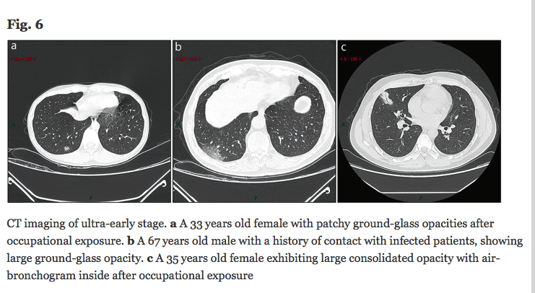(12)
  - Early stage.
    - This stage refers to the period of 1–3 days after clinical manifestations (fever, cough, dry cough, etc.).(12)
    - The pathological process during this stage is dilatation and congestion of alveolar septal capillary, exudation of fluid in alveolar cavity and interlobular interstitial edema (12)
    - It showed that single or multiple scattered patchy or agglomerated ground-glass opacities, separated by honeycomb-like or grid-like thickened of interlobular septa (12)

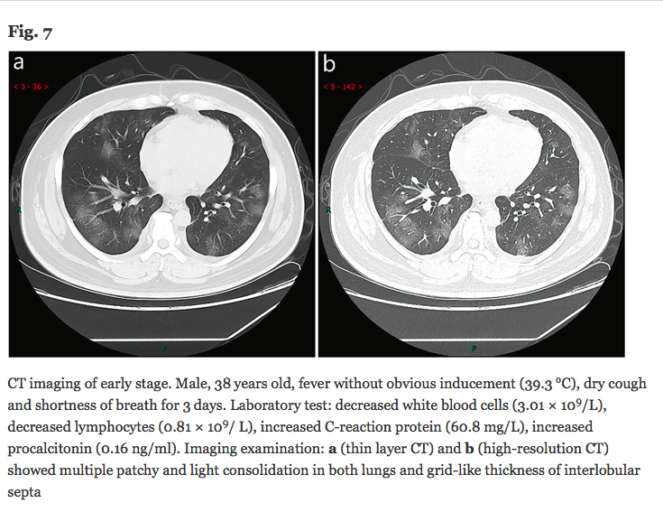(12)
  - Rapid progression stage.
    - This stage refers to the period about 3–7 days after clinical manifestations started, the pathological features in this stage are the accumulation of a large number of cell-rich exudates in the alveolar cavity, vascular expansion and exudation in the interstitium, both of which lead to further aggravation of alveolar and Interstitial edema(12)
    - The fibrous exudation connects each alveolus through the inter-alveolar space to form a fusion state(12)
    - The CT manifested a fused and large-scale light consolidation with air-bronchogram inside (12)

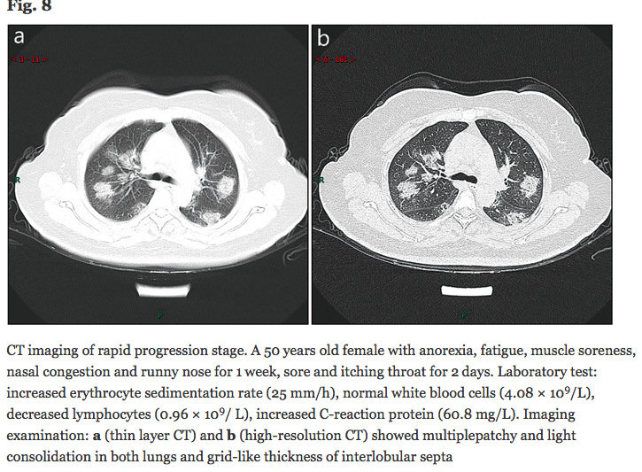(12)
  - Consolidation stage.
    - This stage refers to the period around 7–14 days after clinical manifestations appeared (12)
    - The main pathological features in this stage are the fibrous exudation of the alveolar cavity and the disappearance of capillary congestion in the alveolar wall(12)
    - CT imaging showed the multiple patchy consolidations in slighter density and smaller range than that of the previous stage.(12)

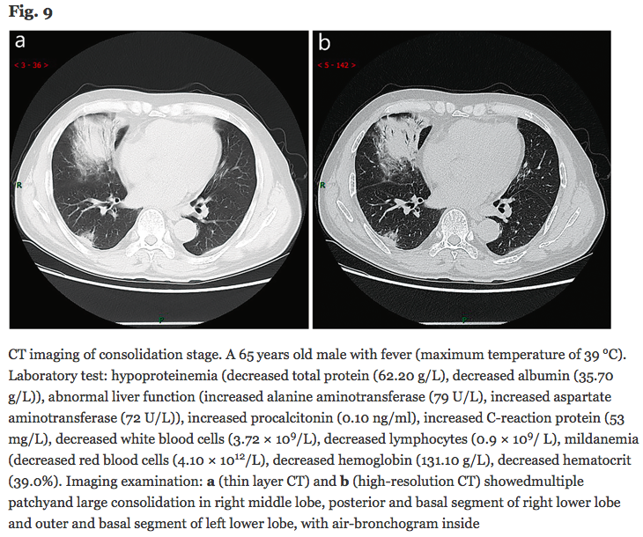
  - Dissipation stage.
    - This stage refers to the period roughly between 2 and 3 weeks after the onset of clinical manifestations (12)
    - The range of lesions was further reduced(12)
    - CT imaging showed patchy consolidation or strip-like opacity(12)
    - As time goes on, it showed grid-like thickening of interlobular septum, thickening and strip-like twist of bronchial wall and a few scattered patchy consolidations (12)
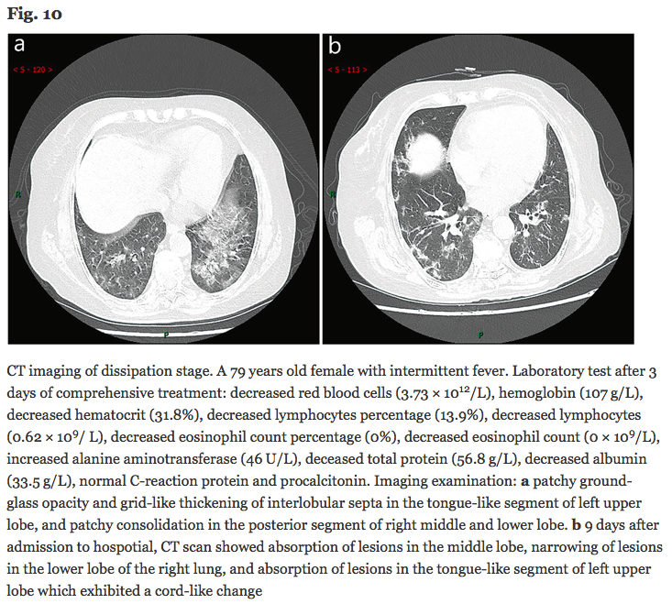(12)

Laboratory Data
- Lymphocytopenia was present in 83.2% of the patients on admission.(2)
  - Compared with 120 healthy check-ups, the absolute value of lymphocyte (0.87 vs 2.13) × 109/L, lymphocyte percentage (19.5% vs 33.7%), eosinophil percentage (0.13% vs 2.16%), and absolute value (0.0061 vs 0.1417) × 109/L in 2019-nCoV patients were significantly reduced (P < 0.05) (12)
- Leukocytes increased 24% (4)
  - Neutrophils increased 38% (4)
- thrombocytopenia in 36.2% (2)
- less common were elevated levels of alanine aminotransferase, aspartate aminotransferase, creatine kinase, and d-dimer(2)
- Albumin decreased in 98% (4)
- Serum creatinine decreased in 23% (4)
- LDH increased in 76% (4)
- Glucose increased in 51% (4)
- Infection related Biomarkers
  - Procalcitonin increased 6% (4)
  - Serum Ferritin increased 63% (4)
  - ESR increased in 84% (4)
  - CRP increased in 86% (4), (2)
- CO-Infection
  - Other Viruses 0 (4)
  - Bacteria 1% (4)
  - Fungus 4% (4)
  - Common bacterial cultures of patients with secondary infections included A baumannii, K pneumoniae, A flavus, C glabrata, and C albicans (4)
- Patients with severe disease had more prominent laboratory abnormalities (including lymphocytopenia and leukopenia) than those with nonsevere disease. (2)

Treatment
- Patients with mild disease do not require hospital interventions, but isolation is necessary to contain virus transmission and will depend on national strategy and resources. (10)
- Give supplemental oxygen therapy immediately to patients with SARI and respiratory distress, hypoxaemia or shock and target SpO2 > 94%. (10)
- Use conservative fluid management in patients with SARI when there is no evidence of shock.
- IVF
  - Patients with SARI should be treated cautiously with intravenous fluids, because aggressive fluid resuscitation may worsen oxygenation, especially in settings where there is limited availability of mechanical ventilation. This applies for care of children and adults. (10)
- Oxygenation and Ventilation
  - Because of uncertainty around the potential for aerosolization, HFO, NIV, including bubble CPAP, should be used with airborne precautions until further evaluation of safety can be completed (10)
- Steroids?
  - NO! (short answer)
  - Do not routinely give systemic corticosteroids for treatment of viral pneumonia outside clinical trials.(10)
    - A systematic review of observational studies of corticosteroids administered to patients with SARS reported no survival benefit and possible harms (avascular necrosis, psychosis, diabetes, and delayed viral clearance). (10)
    - A systematic review of observational studies in influenza found a higher risk of mortality and secondary infections with corticosteroids; the evidence was judged as very low to low quality owing to confounding by indication (10)
    - A recent study of patients receiving corticosteroids for MERS used a similar statistical approach and found no effect of corticosteroids on mortality but delayed LRT clearance of MERS-CoV (10)
    - Given the lack of effectiveness and possible harm, routine corticosteroids should be avoided unless they are indicated for another reason.(10)
      - Other reasons may include exacerbation of asthma or COPD, septic shock, and risk/benefit analysis needs to be conducted for individual patients. (10)
  - Shock dose steroids for patients with septic shock?
    - Still probably no - short answer
    - Long answer - Clinicians considering corticosteroids for a patient with COVID- 19 and sepsis must balance the potential small reduction in mortality with the potential downside of prolonged shedding of coronavirus in the respiratory tract, as has been observed in patients with MERS (10)
  - Steroids in pregnant individuals for fetal lung development?
    - Still no-ish?
    - WHO recommends antenatal corticosteroid therapy for women at risk of preterm birth from 24 to 34 weeks of gestation when there is no clinical evidence of maternal infection, and adequate childbirth and newborn care is available (10)
    - However, in cases where the woman presents with mild COVID-19, the clinical benefits of antenatal corticosteroid might outweigh the risks of potential harm to the mother (10)
      - In this situation, the balance of benefits and harms for the woman and the preterm newborn should be discussed with the woman to ensure an informed decision, as this assessment may vary depending on the woman’s clinical condition, her wishes and that of her family, and available health care resources (10)
  - WHO currently recommends against routine use of corticosteroids in patients with SARS- CoV-2, as available data suggest corticosteroids are associated with no survival benefit and possible harm. (11)
  - CPAM states that use of corticosteroids is controversial and should therefore be used with caution. (11)
- Drugs
  - According to the World Health Organization (WHO), the Centers for Disease Control and Prevention (CDC), and the U.S. Food and Drug Administration (FDA), there are currently no medications or vaccines proven to be effective for the treatment or prevention of the 2019 severe acute respiratory syndrome coronavirus 2 (SARS-CoV-2) (11)
  - For direct antiviral treatment of SARS-CoV-2, China International Exchange and Promotive Association for Medical and Health Care (CPAM) recommends use of lopinavir; ritonavir [2 capsule (dose undefined) by mouth twice daily] in combination with nebulized alfa-interferon (5 million units in Sterile Water for Injection inhaled twice daily) (11)
    - CPAM has based this recommendation on weak evidence from retrospective cohort, historically controlled studies, case reports, and case series that suggest clinical benefit of lopinavir; ritonavir in the treatment of other coronavirus infection (11)
  - a group of Korean physicians with experience in treating SARS-CoV-2 infected patients have developed recommendations for the treatment of COVID-19 (11)
    - According to these physicians, antiviral medications are not recommended for use in young, healthy patients with mild symptoms and no underlying comorbid conditions (11)
    - Treatment with lopinavir 400 mg; ritonavir 100 mg (2 tablets by mouth twice daily) or chloroquine (500 mg by mouth twice daily) should be considered for use in older patients or patients with under underlying conditions and serious symptoms (11)
    - If chloroquine is unavailable, they recommend considering use of hydroxychloroquine (400 mg by mouth once daily)(11)
    - Use of ribavirin and interferon were not recommended as first-line treatments because of the risk for side effects; however, use of these medications may be considered if treatment with lopinavir; ritonavir, chloroquine, or hydroxychloroquine are ineffective (11)
  - Remdesivir (GS-5734), an investigational nucleoside analogue (5), (11):
    - Remdesivir has been administered to several hundred patients with confirmed,severe SARS-CoV-2 infections in the United States, Europe, and Japan through Expanded Access or Compassionate Use programs. (11)
    - A clinical trial evaluating the efficacy of remdesivir in patients infected with SARS-CoV-2 is currently being conducted in China. Data from this trial are expected by April 2020. (11)
    - In preclinical trials, remdesivir has demonstrated significant activity against coronavirus and a high genetic barrier to resistance. (11)
    - In vitro data found remdesivir exerts potent antiviral activity against a clinical isolate of SARS-CoV-2; [half-maximal effective concentration (EC50) = 0.77 mcgM, half-cytotoxic concentration (CC50) > 100 mcgM , selective index (SI) > 129.87]. (11)
    - Data suggest remdesivir (GS-5735) inhibits activity of 2002 SARS-CoV, MERS- CoV, and bat CoV strains that have the ability to replicate in human epithelial cells and mediate entry via human CoV receptors.(11), (5)
    - Remdesivir has shown prophylactic and therapeutic efficacy against 2002 SARS- CoV in a mouse model. (11)
    - Resistance mutations have not been identified. (11)
  - Sofosbuvir in combination with ribavirin:
    - Data from a molecular docking experiment using the SARS-CoV-2 RNA dependent RNA polymerase (RdRp) model identified tight binding of sofosbuvir and ribavirin to the coronavirus RdRp, thereby suggesting possible efficacy of sofosbuvir and ribavirin in treating the COVID-19 infection. (11)
  - Baricitinib
    - Because the plasma concentration of baricitinib on therapeutic dosing (either as 2 mg or 4 mg once daily) is sufficient to inhibit AAK1, it could be trialled, using an appropriate patient population with 2019-nCoV acute respiratory disease, to reduce both the viral entry and the inflammation in patients, using endpoints such as the MuLBSTA score, an early warning model for predicting mortality in viral pneumonia. (3)
  - A recent systematic review showed that lopinavir/ritonavir’s anti-coronavirus effect was mainly seen in its early application, for reducing patient mortality and reduced glucocorticoid consumption. (12)
    - However, if the early treatment window is missed, there will be no significant effect in their late application(12)
  - Use of intravenous immunoglobulin is recommended to enhance the ability of anti-infection for severely ill patients and steroids (methylprednisolone 1–2 mg/kg per day) are recommended for patients with ARDS, for as short a duration of treatment as possible (4)
  - TREATMENTS FOR THE 2002 SAR! (not this one but may still be useful information)
    - Interferon alfacon-1 in conjunction with corticosteroids (11)
      - Open-label trial comparing the therapeutic benefit and tolerability of interferon alfacon- 1 plus corticosteroids in 9 patients with probable 2002 SARS-CoV to treatment with corticosteroids alone (n = 13) (11)
      - Primary outcome: clinical parameters, including oxygen saturation/requirements, laboratory results, and serial chest radiograph results (11)
        - The interferon alfacon-1 treatment group had shorter time to 50% resolution of pulmonary radiograph abnormalities (median time, 4 days vs. 9 days, p = 0.001), better oxygen saturation (p = 0.02), shorter duration of supplemental oxygen (median time, 10 days vs. 16 days, p = 0.02), less increase in creatine kinase (p = 0.03), and trended towards faster resolution of lactate dehydrogenase. (11)
        - Resolution of fevers and lymphopenia were similar between the two groups. (11)
    - Ribavirin in conjunction with corticosteroids (n = 75) (11)
      - Prospective observational study of 2002 SARS-CoV infected patients who received treatment with ribavirin (14 days) and corticosteroids (21 days); clinical outcomes were followed for 3 weeks (11)
      - After Initial Improvement Of Fever And Pneumonia,85%of patients developed recurrent fever after 8.9 days, 73% had watery diarrhea after 7.5 days, 80% had radiological worsening after 7.4 days, and 45% had worsening respiratory symptoms after 8.6 days. In 45% of patients, improvement of initial pulmonary lesions was associated with appearance of new radiographic lesions at other sites (11)
      - After Three Weeks, 12% developed spontaneous pneumomediastinum and 20% developed acute respiratory distress syndrome (ARDS). (11)
    - Lopinavir; ritonavir in conjunction with ribavirin and corticosteroids
      - Open-label trial involving newly diagnosed 2002 SARS-CoV patients who had not developed acute respiratory distress syndrome (ARDS) (11)
      - Primary outcome: Composite adverse outcome described as severe hypoxia and or death at day 21 (11)
        - Historical controls: 22.5% met criteria for hypoxemia, 6.3% died (11)
        - Treatment group: 2.4% met criteria for hypoxemia, no deaths were reported (11)
        - 21-day adverse outcome rate: 28.8% for historical controls and 2.4% for treatment group (26.4%, 95% CI: 16.8 to 36, p < 0.001) (11)
- Vaccine
  - A robust research effort is currently underway to develop a vaccine against Covid-19. Anticipate that the first candidates will enter phase 1 trials by early spring (6)
- Once available, intravenous hyperimmune globulin from recovered persons and monoclonal antibodies may be attractive candidates to study in early intervention (6)
- Extracorporeal Membrane Oxygenation (ECMO) should be considered for the patients with refractory hypoxemia that is difficult to be corrected by protective lung ventilation. (12)
- Drugs to avoid?
  - ACE I?
    - We therefore hypothesise that diabetes and hypertension treatment with ACE2-stimulating drugs increases the risk of developing severe and fatal COVID-19 (16)
  - ACE2 can also be increased by thiazolidinediones and ibuprofen (16)

Works Cited

1. “Public Health Media Library.” Centers for Disease Control and Prevention, Centers for Disease Control and Prevention, tools.cdc.gov/medialibrary/index.aspx#/microsite/id/403323.
2. Guan, Wei-Jie, et al. “Clinical Characteristics of Coronavirus Disease 2019 in China.” New England Journal of Medicine, 2020, doi:10.1056/nejmoa2002032.
3. Richardson, Peter, et al. “Baricitinib as Potential Treatment for 2019-NCoV Acute Respiratory Disease.” The Lancet, vol. 395, no. 10223, 2020, doi:10.1016/s0140-6736(20)30304-4.
4. Chen, Nanshan, et al. “Epidemiological and Clinical Characteristics of 99 Cases of 2019 Novel Coronavirus Pneumonia in Wuhan, China: a Descriptive Study.” The Lancet, vol. 395, no. 10223, 2020, pp. 507–513., doi:10.1016/s0140-6736(20)30211-7.
5. “COVID-19.” Gilead Creating Possible, www.gilead.com/purpose/advancing-global-health/covid-19.
6. Fauci, Anthony S., et al. “Covid-19 - Navigating the Uncharted: NEJM.” New England Journal of Medicine, 29 Jan. 2020, www.nejm.org/doi/full/10.1056/NEJMe2002387.
7. Rothe, C., et al. “SARS-CoV-2 Viral Load in Upper Respiratory Specimens of Infected Patients: NEJM.” New England Journal of Medicine, 5 Mar. 2020, www.nejm.org/doi/full/10.1056/NEJMc2001737.
8. Coronavirus testing, mortality, vaccine development, containment vs mitigation, and more. Anthony S. Fauci, MD discusses the latest developments in the global spread of COVID-19 and the SARS-CoV-2 virus with JAMA Editor Howard Bauchner, MD.
9. Community, The Elsevier. “Novel Coronavirus Information Center.” Elsevier Connect, Elsevier, 13 Mar. 2020, www.elsevier.com/connect/coronavirus-information-center.
10. “Clinical Management of Severe Acute Respiratory Infection When Novel Coronavirus (NCoV) Infection Is Suspected.” World Health Organization, World Health Organization, www.who.int/publications-detail/clinical-management-of-severe-acute-respiratory-infection-when-novel-coronavirus-(ncov)-infection-is-suspected.
11. Smith, PharmD, BCPS, Tim, and Tony Prosser, PharmD. “COVID-19 Drug Therapy — Potential Options.” Https://Www.elsevier.com/__data/Assets/pdf_file/0007/988648/COVID-19-Drug-Therapy_Mar-2020.Pdf, Elsevier, Mar. 2020.
12. Norris, et al. “A Rapid Advice Guideline for the Diagnosis and Treatment of 2019 Novel Coronavirus (2019-NCoV) Infected Pneumonia (Standard Version).” Military Medical Research, BioMed Central, 1 Jan. 1970, mmrjournal.biomedcentral.com/articles/10.1186/s40779-020-0233-6.
13. Chen, Ming, et al. “Clinical Characteristics of Coronavirus Disease 2019 (COVID-19) in Patients out of Wuhan from China.” The Lancet, 3 Mar. 2020, doi:10.21203/rs.3.rs-15449/v1.
14. Chen, Chen, et al. “SARS-CoV-2: a Potential Novel Etiology of Fulminant Myocarditis.” Herz, 2020, doi:10.1007/s00059-020-04909-z.
15. Zheng, Ying-Ying, et al. “COVID-19 and the Cardiovascular System.” Nature Reviews Cardiology, 2020, doi:10.1038/s41569-020-0360-5.
16. Fang, Lei, et al. “Are Patients with Hypertension and Diabetes Mellitus at Increased Risk for COVID-19 Infection?” The Lancet Respiratory Medicine, 2020, doi:10.1016/s2213-2600(20)30116-8.
17. Zhang, Jin-Jin, et al. “Clinical Characteristics of 140 Patients Infected with SARS-CoV-2 in Wuhan, China.” Allergy, U.S. National Library of Medicine, 19 Feb. 2020, www.ncbi.nlm.nih.gov/pubmed/32077115/.

Pictures
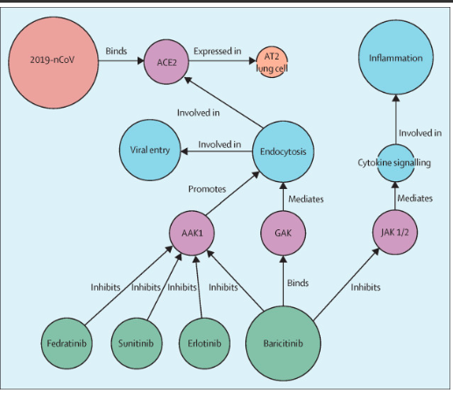
(3)

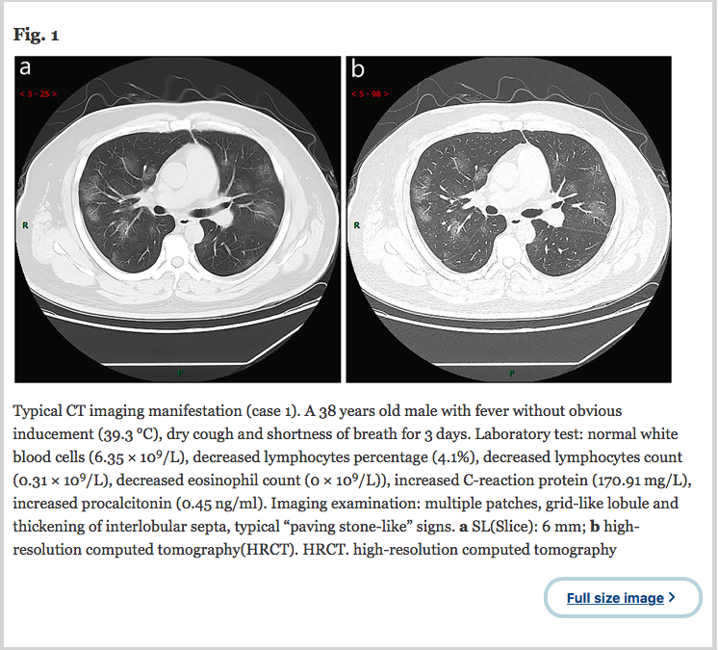
(12)

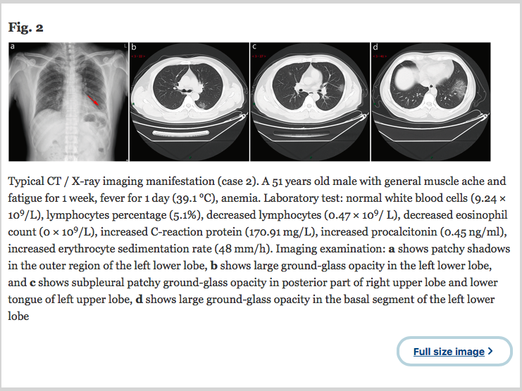
(12)
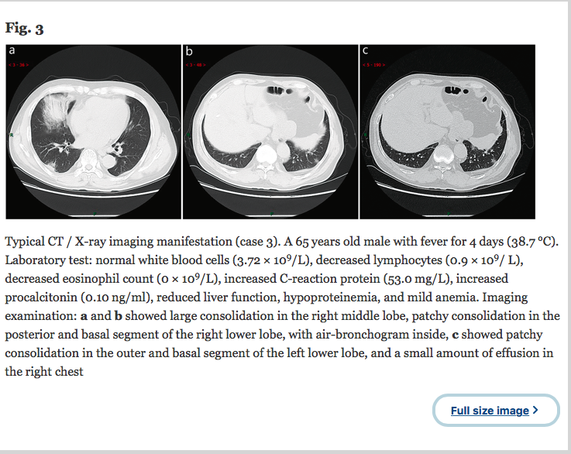
(12)

